Sql queries

1.

CREATE TABLE SalesPeople (

Snum INT NOT NULL PRIMARY KEY,

Sname VARCHAR(50) NOT NULL,

City VARCHAR(50),

Comm FLOAT

);

INSERT INTO SalesPeople

VALUES

(1001,'Peel','London',0.12),

(1002,'Serres','San Jose',0.13),

(1004,'Motika','London',0.11),

(1007,'Rafkin','Barcelona',0.15),

(1003,'Axelrod','New york',0.1);

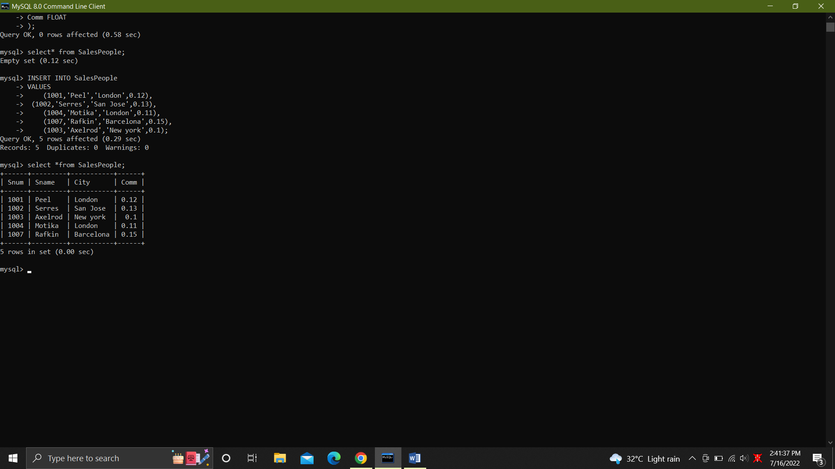

2. CREATE TABLE Customers (

Cnum int NOT NULL,

Cname varchar(50) NOT NULL,

City varchar(50),

Rating int,

Snum int NOT NULL,

CONSTRAINT PK_Customers_Cnum PRIMARY KEY(Cnum),

CONSTRAINT FK_Customers_Snum FOREIGN KEY(Snum) REFERENCES SalesPeople(Snum)

);

insert into Customers

values

(2001,'Hoffman','London',100,1001),

(2002,'Giovanne','Rome',200,1003),

(2003,'Liu','San Jose',300,1002),

(2004,'Grass','Brelin',100,1002),

(2006,'Clemens','London',300,1007),

(2007,'Pereira','Rome',100,1004);

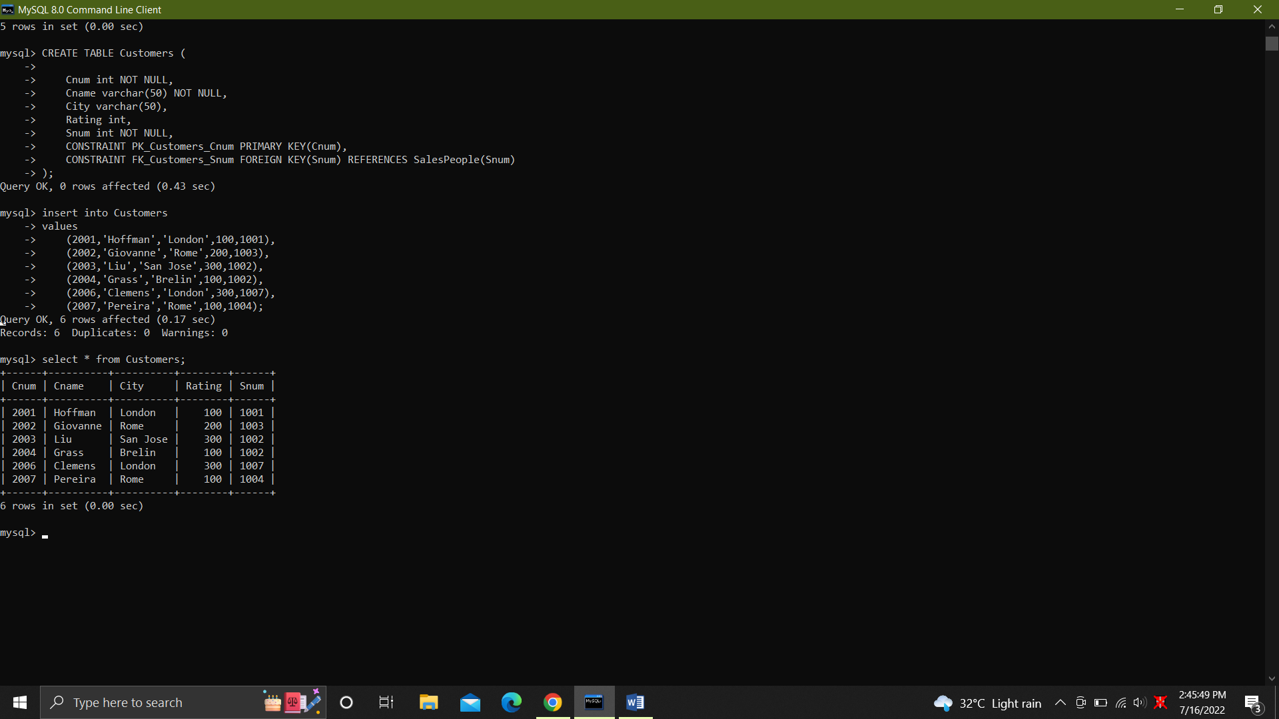

3.

CREATE TABLE Orders (

Onum int NOT NULL,

AMT float NOT NULL,

Odate date NOT NULL,

Cnum int NOT NULL,

Snum int NOT NULL,

constraint PK_Orders_Onum PRIMARY KEY(Onum),

constraint FK_Orders_Cnum FOREIGN KEY(Cnum) REFERENCES Customers(Cnum),

constraint FK_Orders_Snum FOREIGN KEY(Snum) REFERENCES SalesPeople(Snum)

);

Insert into Orders

values

(3001,18.69,'1994-10-03',2004,1007),

(3003,767.19,'1994-10-03',2001,1001),

(3002,1900.10,'1994-10-03',2007,1004),

(3005,5160.45,'1994-10-03',2003,1002),

(3006,1098.16,'1994-10-04',2004,1007),

(3009,1713.23,'1995-10-04',2002,1003),

(3007,75.75,'1994-10=05',2004,1002),

(3008,4723.00,'1994-10-05',2006,1001),

(30010,1309.95,'1994-10-06',2004,1002),

(30011,9891.88,'1994-10-06',2006,1001);

Select * from Orders;

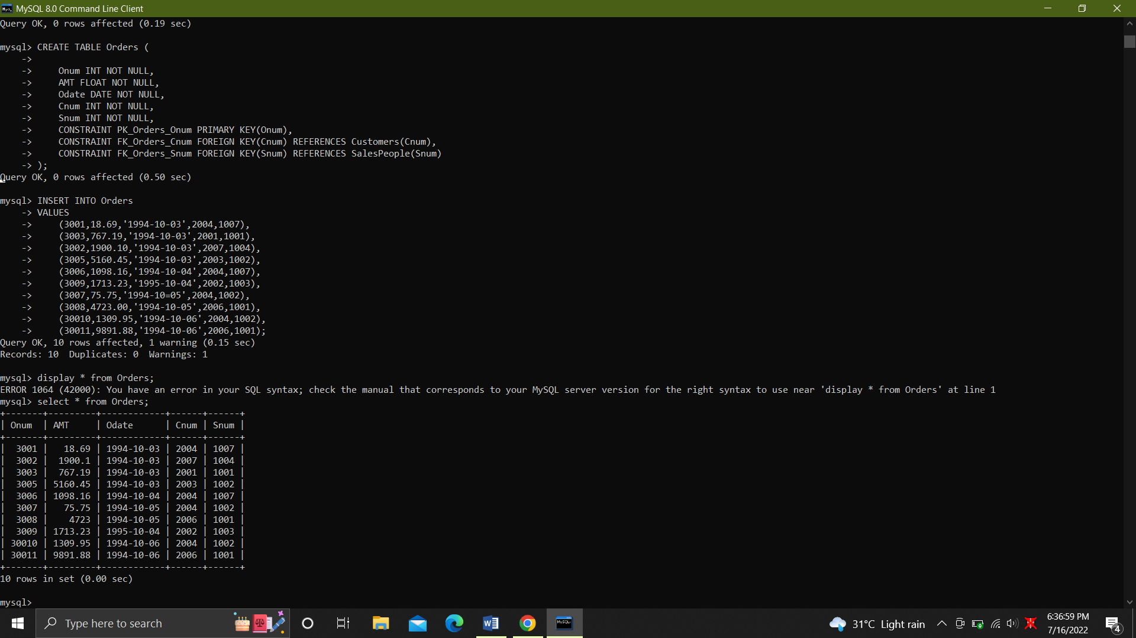

4. .Display snum,sname,city and comm of all salespeople.

SELECT Snum, Snum, City, Comm

FROM SalesPeople;

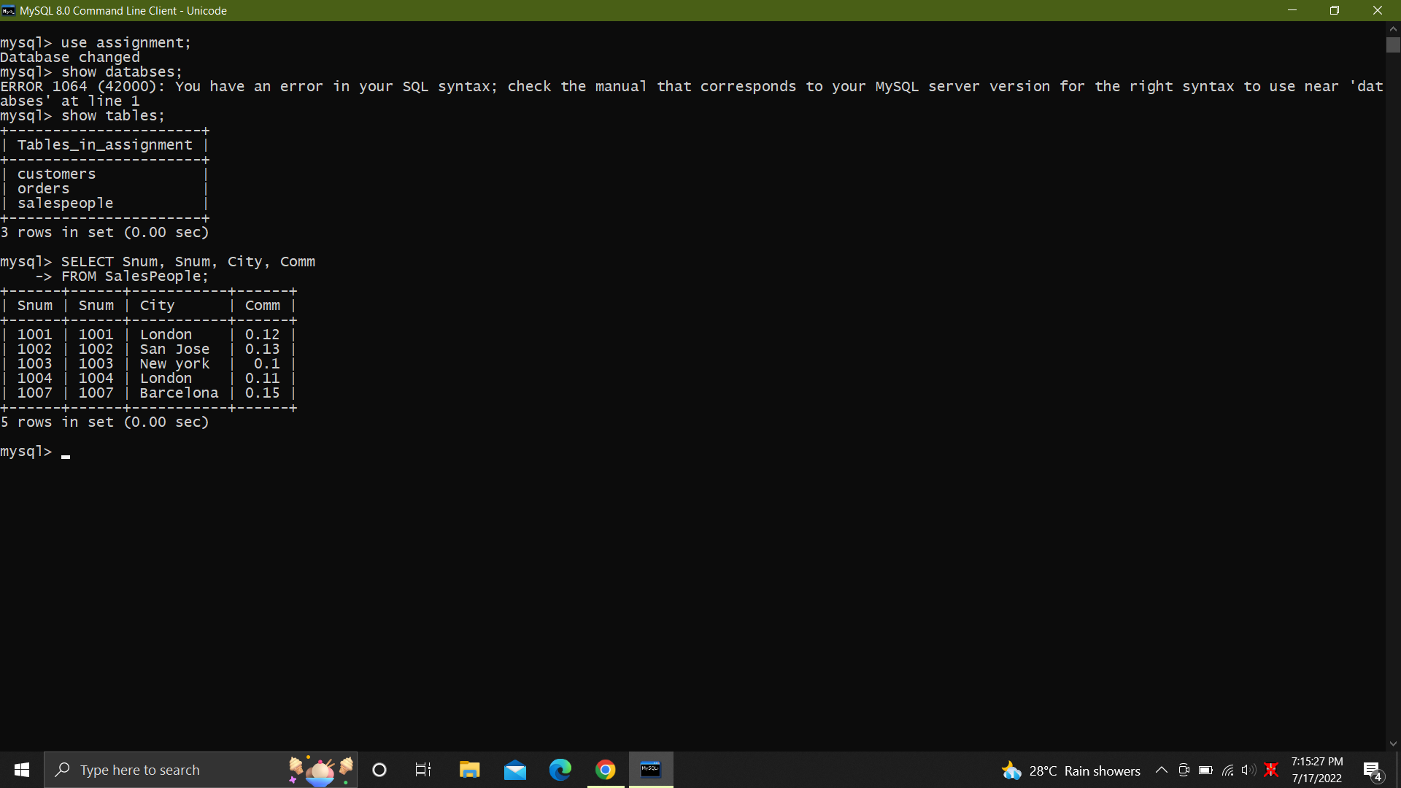

5. SELECT DISTINCT Snum

FROM Orders;

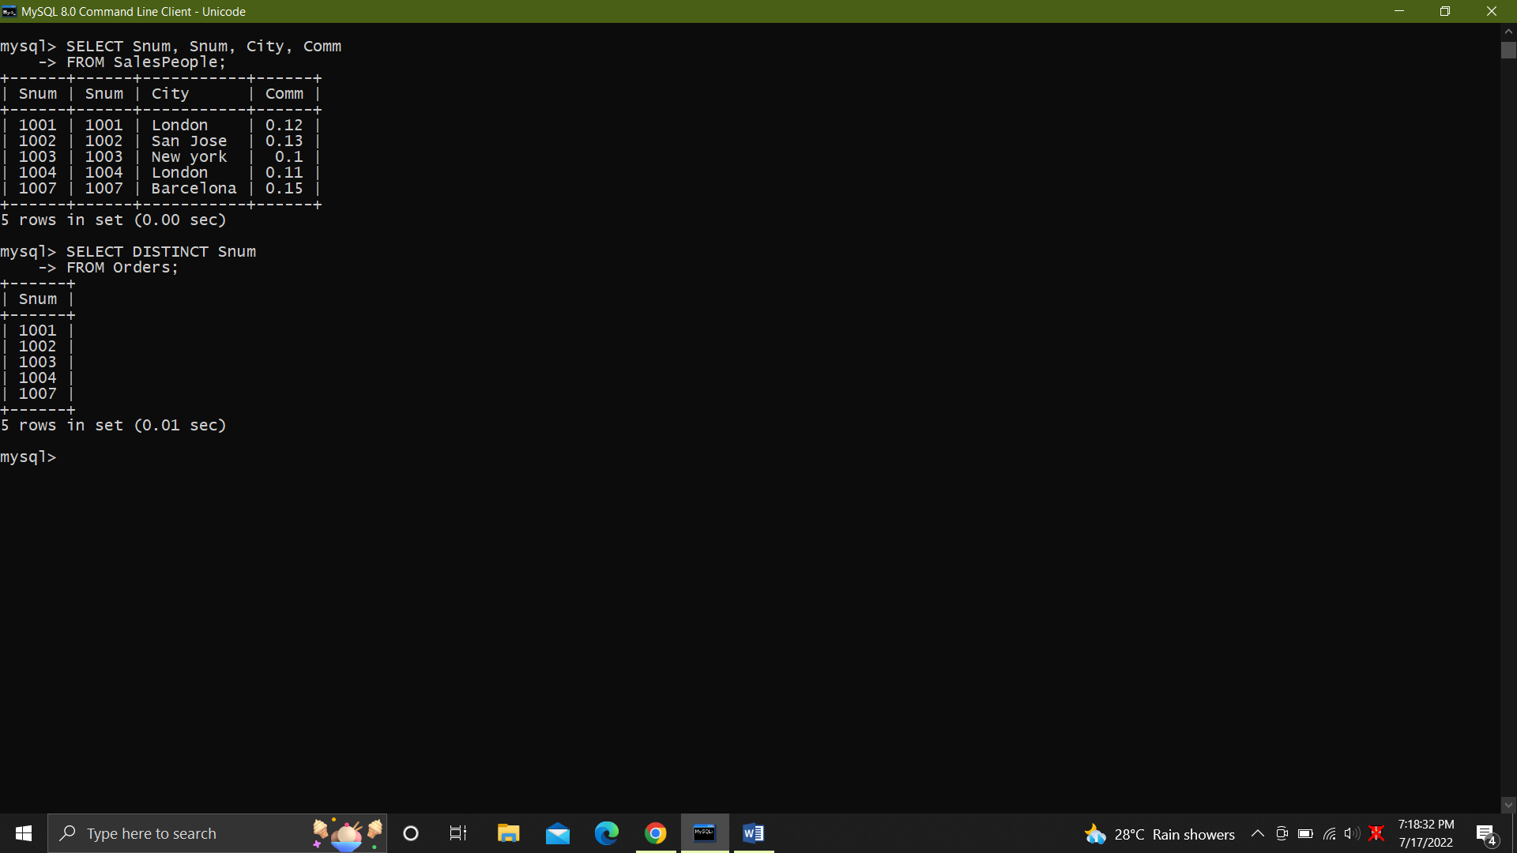

6. Display names and commissions of all salespeople in london.

SELECT Snum, Comm

FROM SalesPeople

WHERE City = 'London';

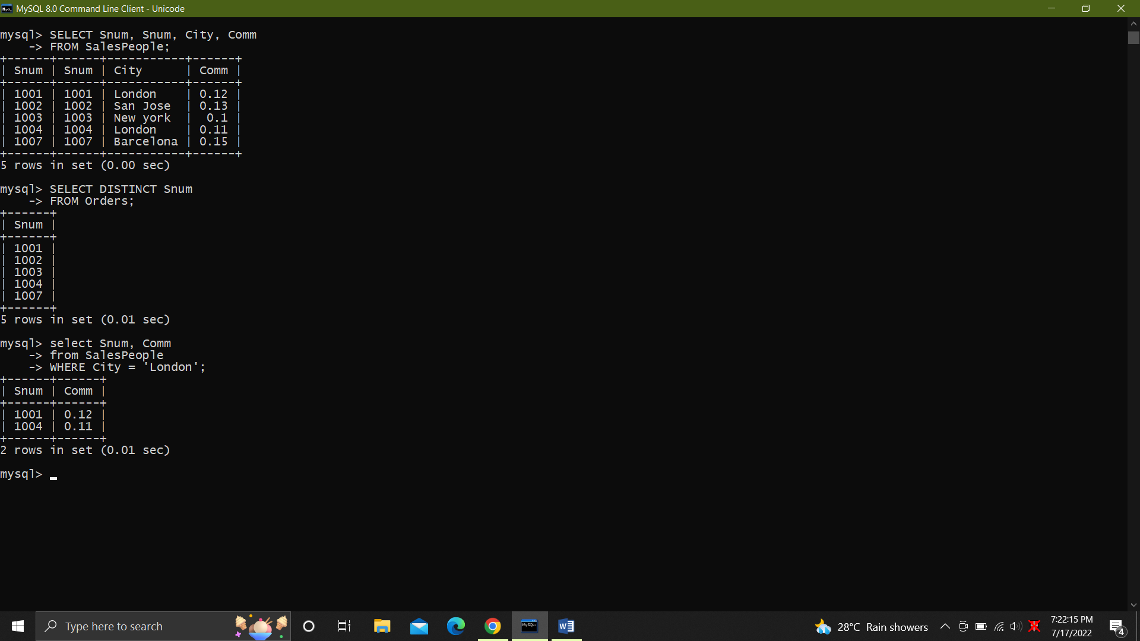

7. All customers with rating of 100.

SELECT Cname

FROM customers

WHERE Rating=100;

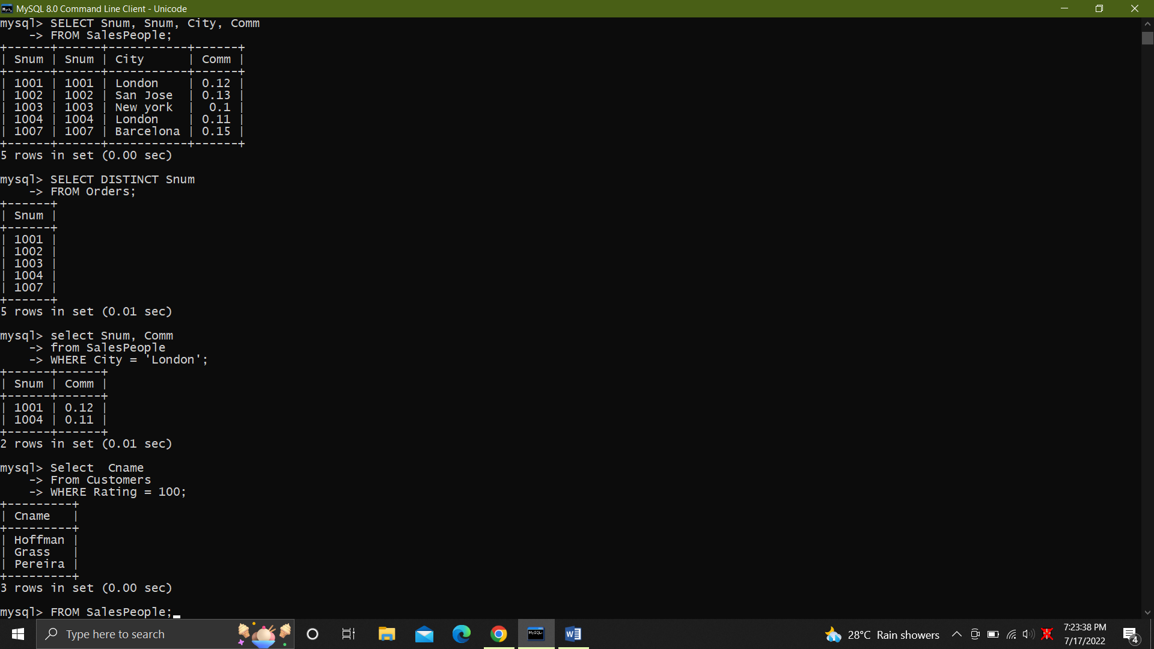

8. Produce orderno, amount and date form all rows in the order table.

SELECT Onum, AMT, Odate

FROM Orders;

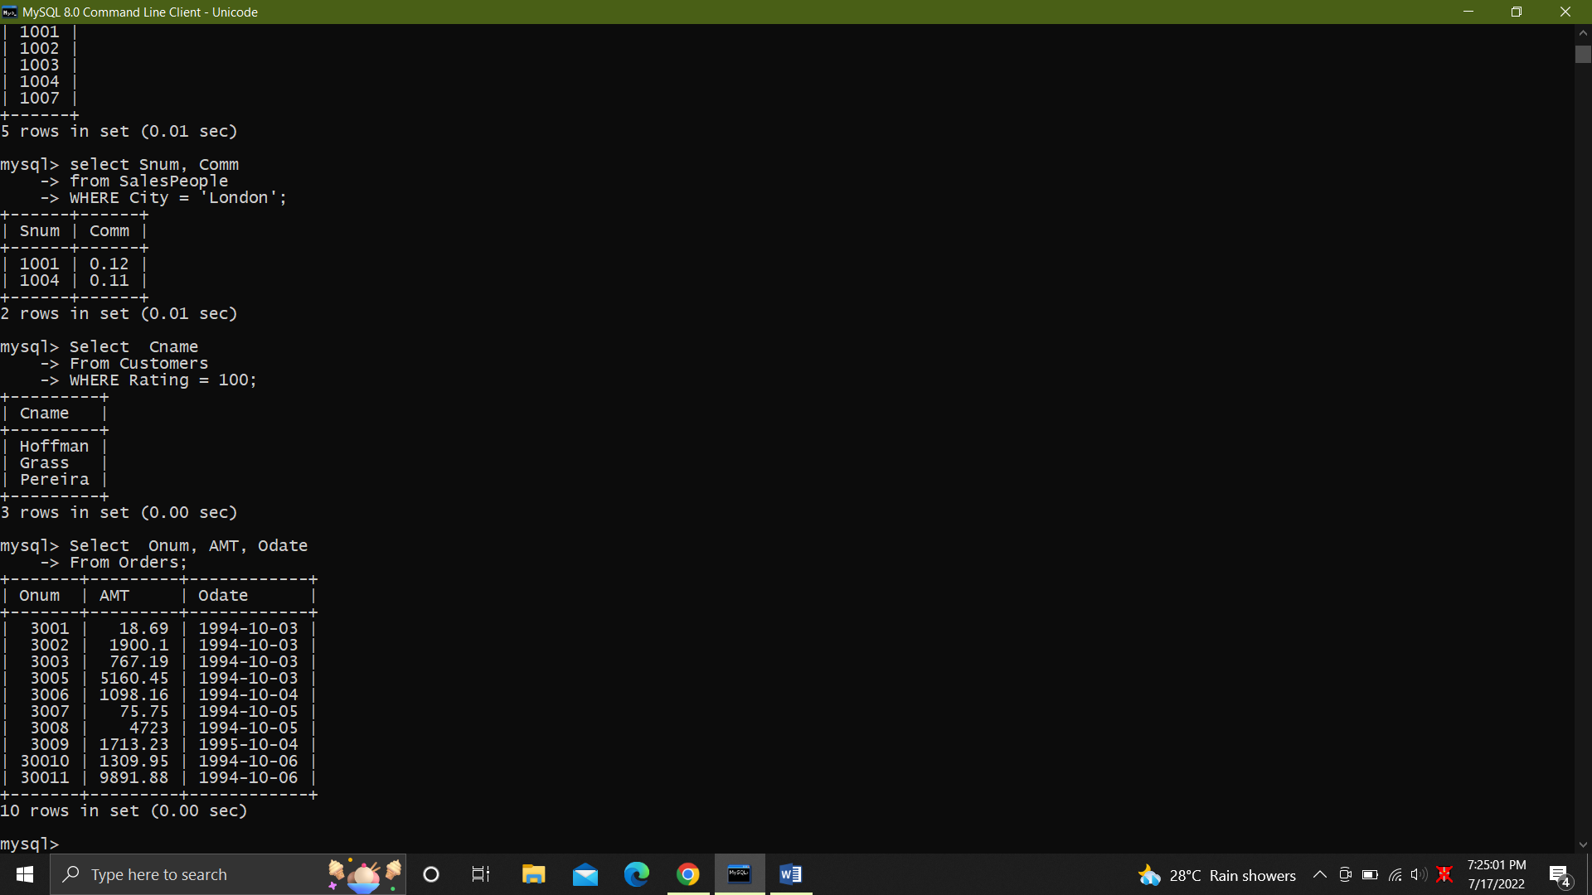

9. All customers in San Jose, who have rating more than 200

SELECT Cname, City, Rating

FROM Customers

WHERE City = 'San Jose' AND Rating > 200;

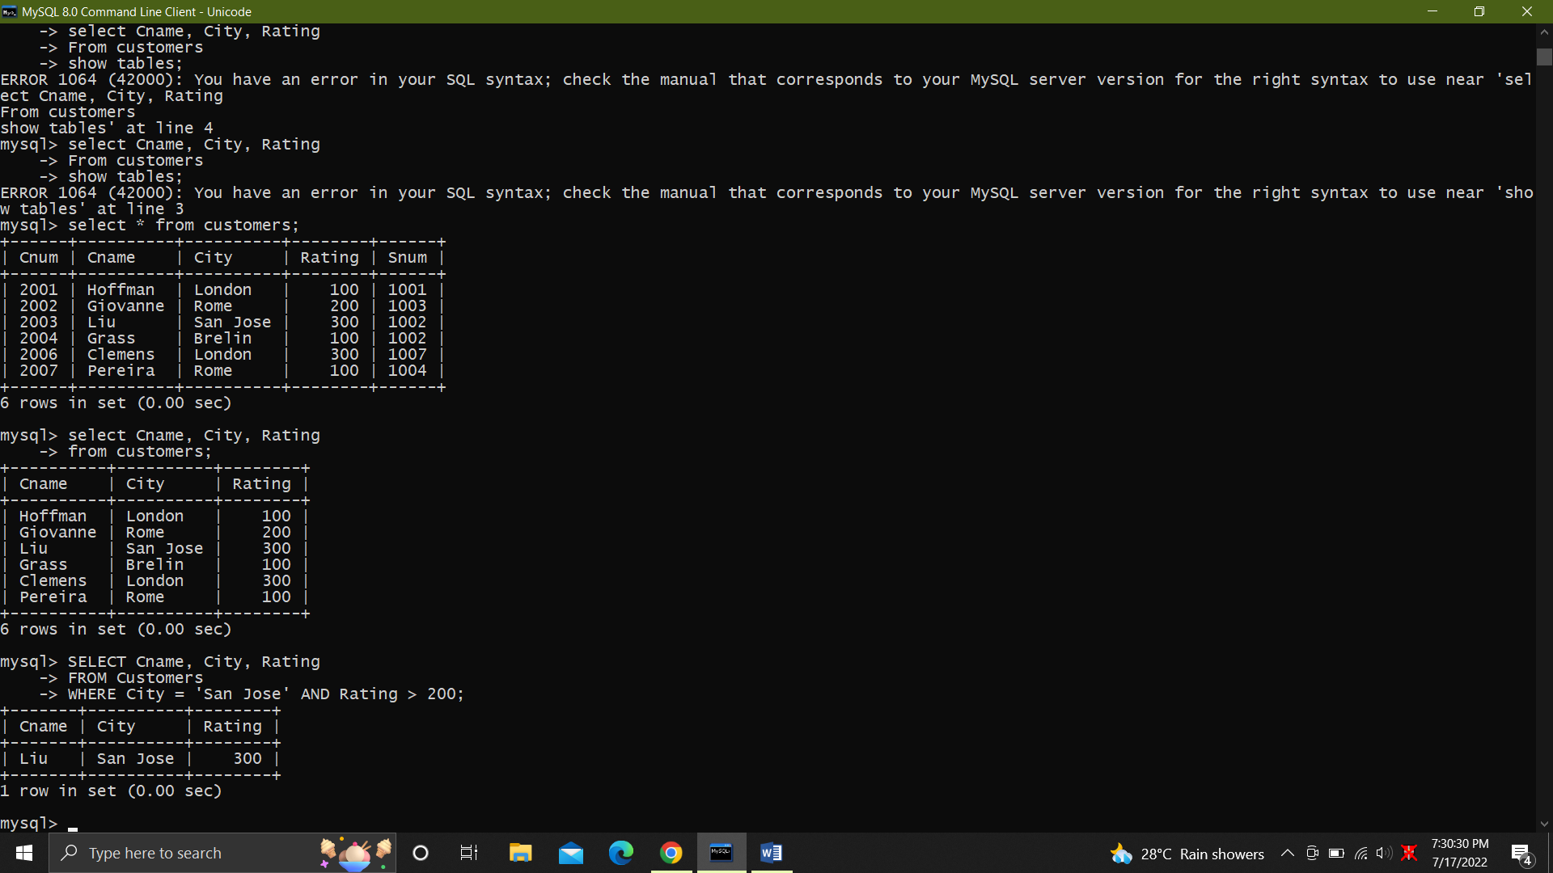

8. All orders for more than $1000.

SELECT *FROM Orders

WHERE AMT > 1000; All orders for more than $1000.

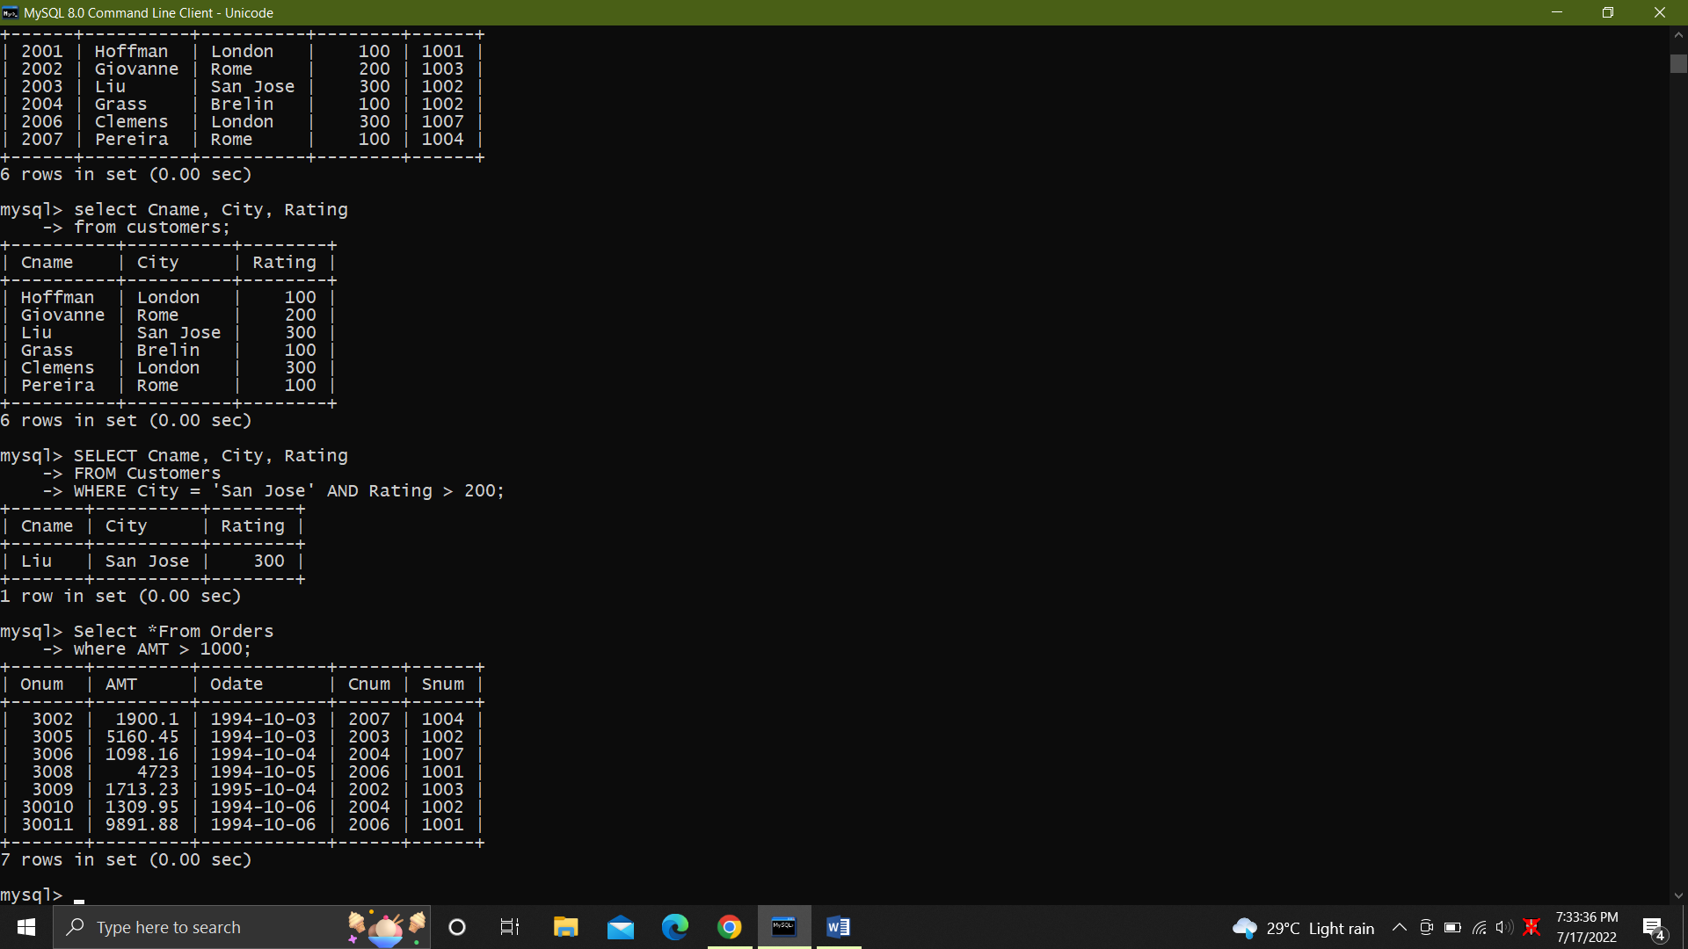

9. Names and cites of all salespeople in london with commission above 0.10.

SELECT Sname, City, Comm

FROM SalesPeople

WHERE City = 'London' AND Comm > 0.10;

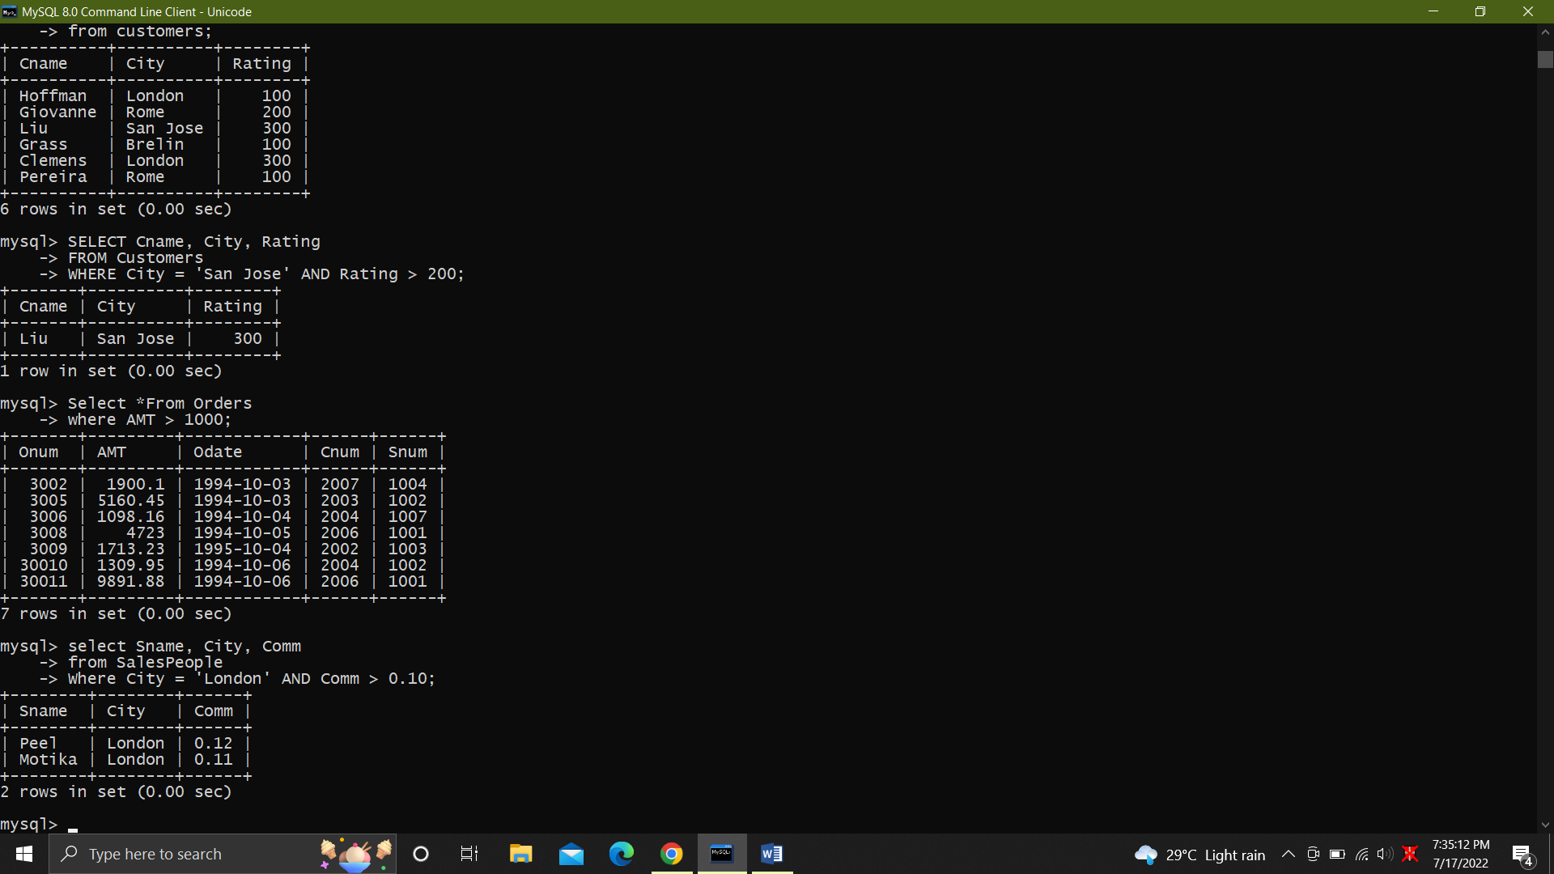

10

Zxdd.All customers excluding those with rating <= 100 unless they are located in Rome

SELECT Cname, City, Rating

FROM Customers

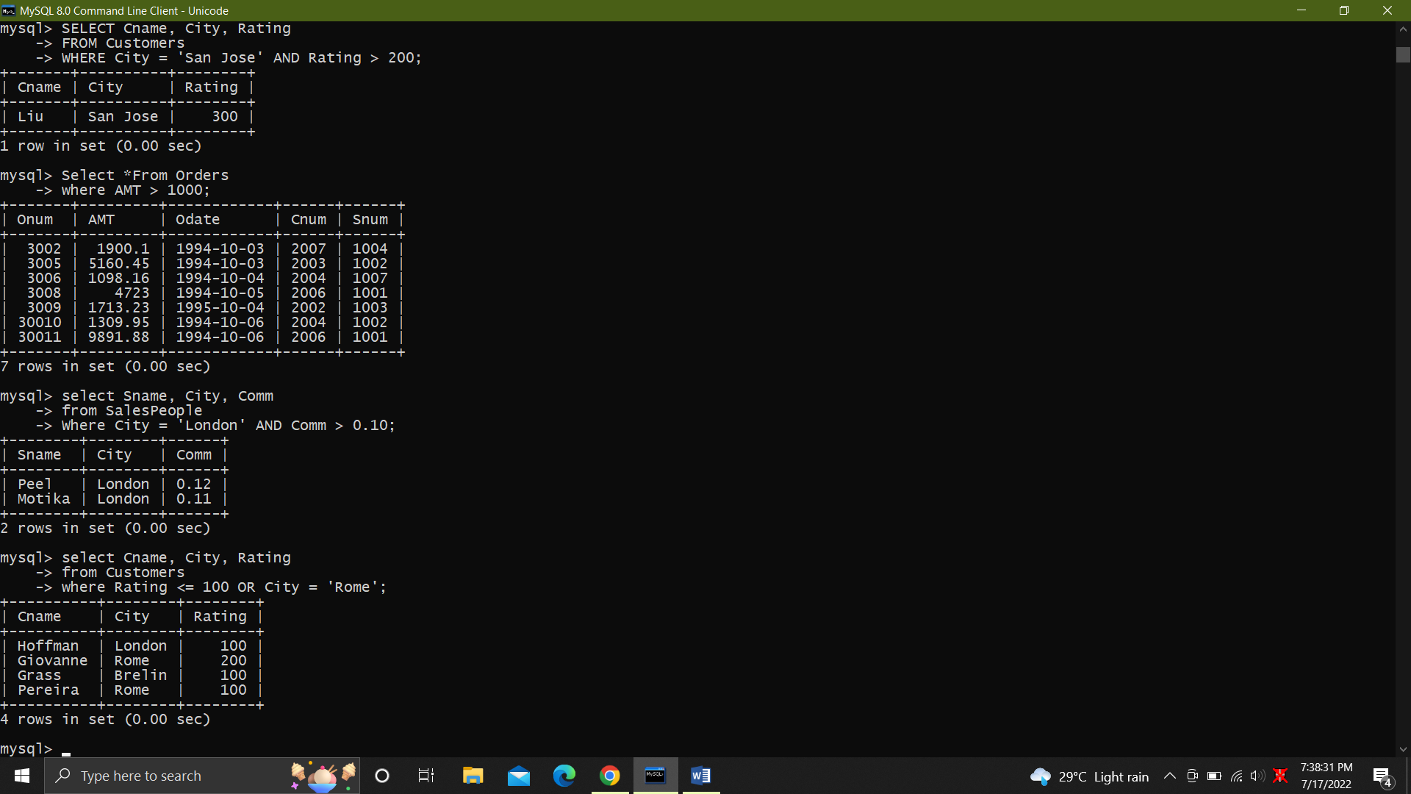

`11. .All salespeople either in Barcelona or in london.

SELECT Sname, City

FROM SalesPeople

WHERE City IN ('Barcelona','london');

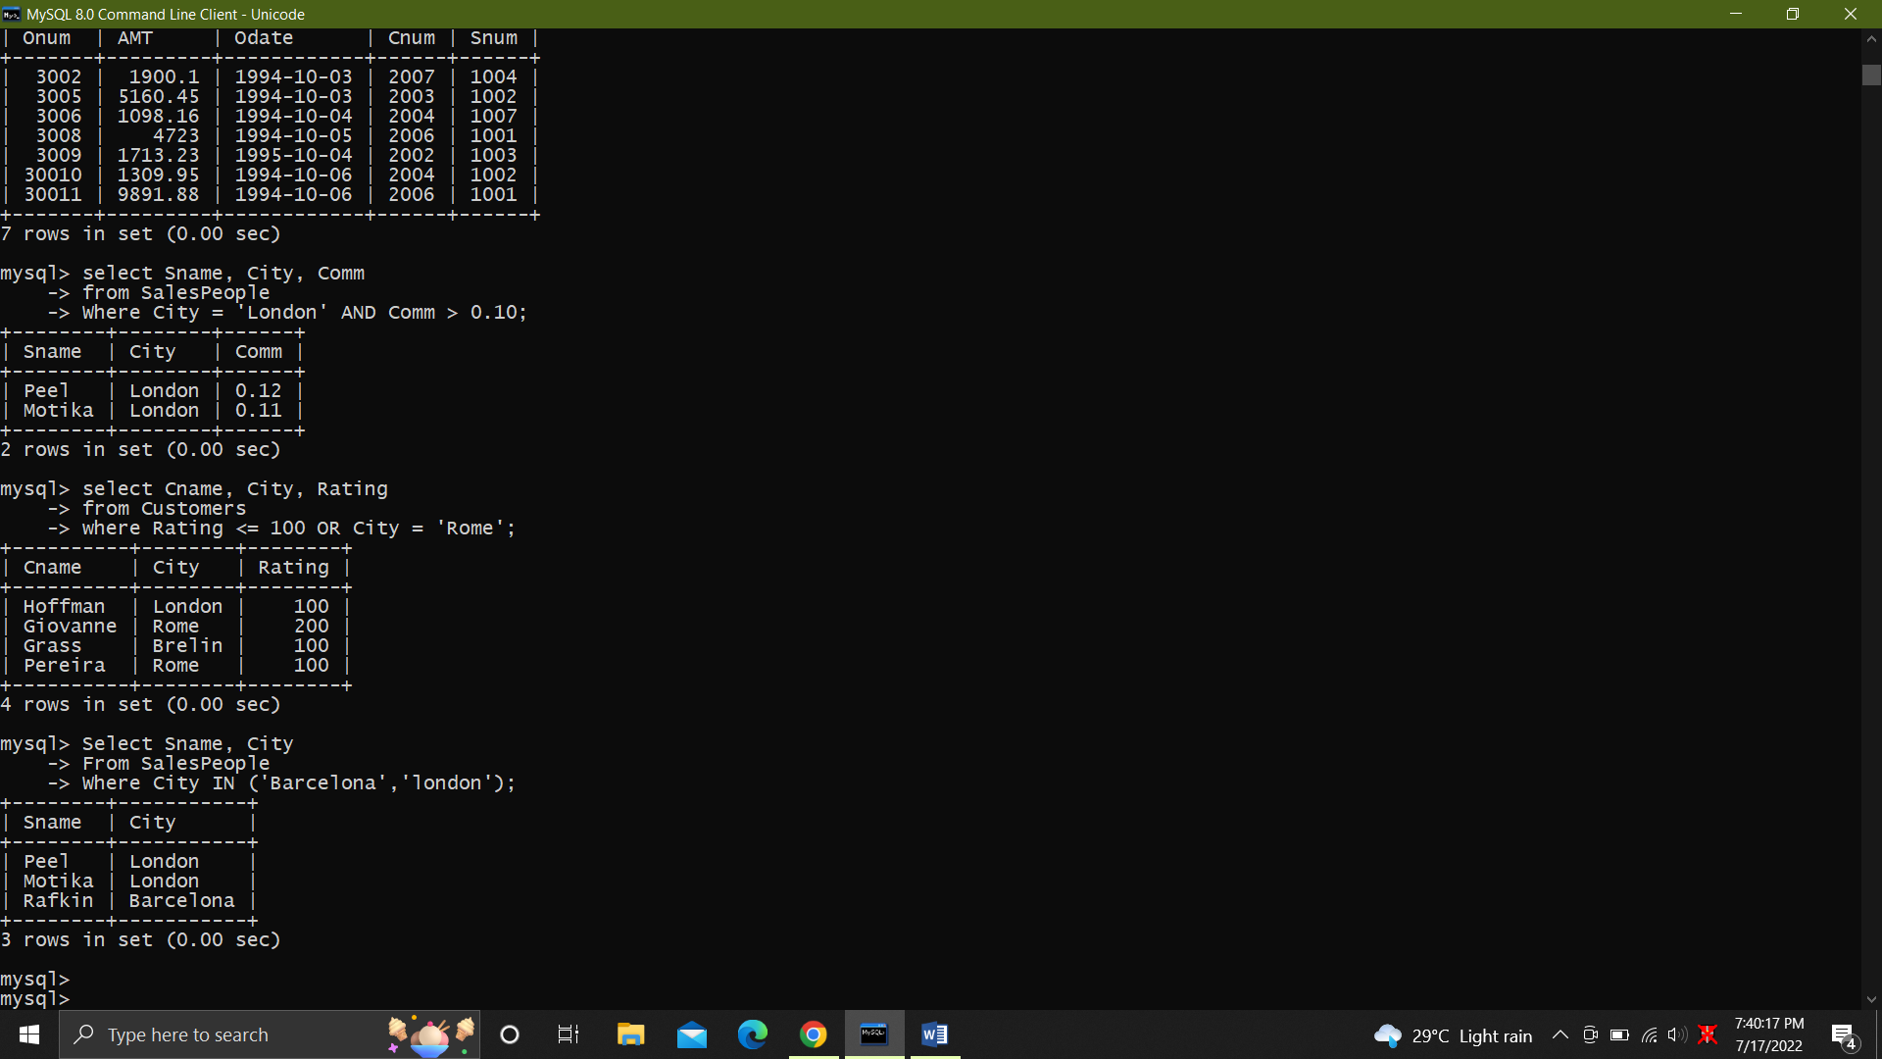

12. All salespeople with commission between 0.10 and 0.12. (Boundary values should be excluded)

SELECT Sname, Comm

FROM SalesPeople

WHERE Comm > 0.10 AND Comm < 0.12;

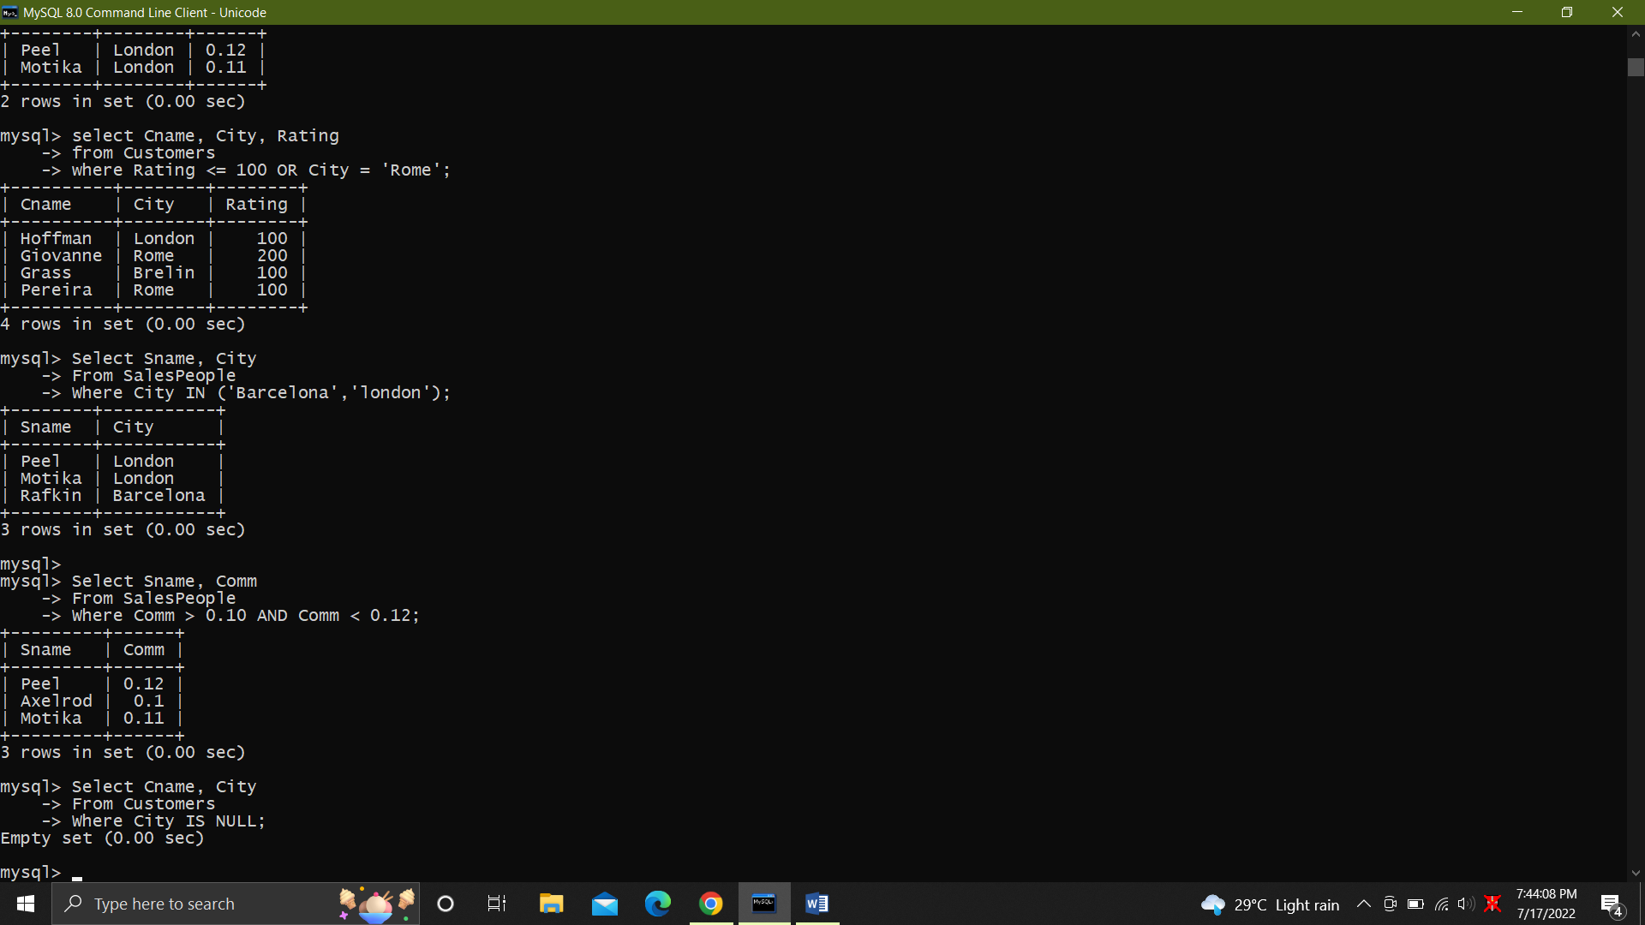

13. All customers with NULL values in city column.

SELECT Cname, City

FROM Customers

WHERE City IS NULL;

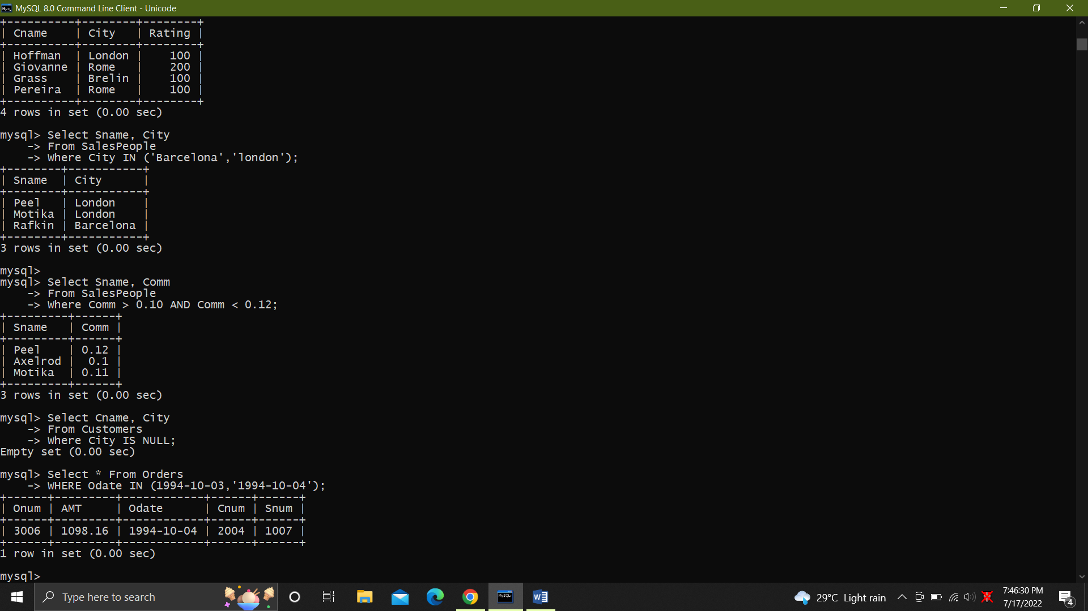

14. .All orders taken on Oct 3Rd and Oct 4th 1994.

SELECT *

FROM Orders

WHERE Odate IN ('1994-10-03','1994-10-04');



15.

SELECT Cname

FROM Customers, Orders

WHERE Orders.Cnum = Customers.Cnum

AND Orders.Snum IN( SELECT Snum FROM SalesPeople WHERE Sname IN ('Peel','M

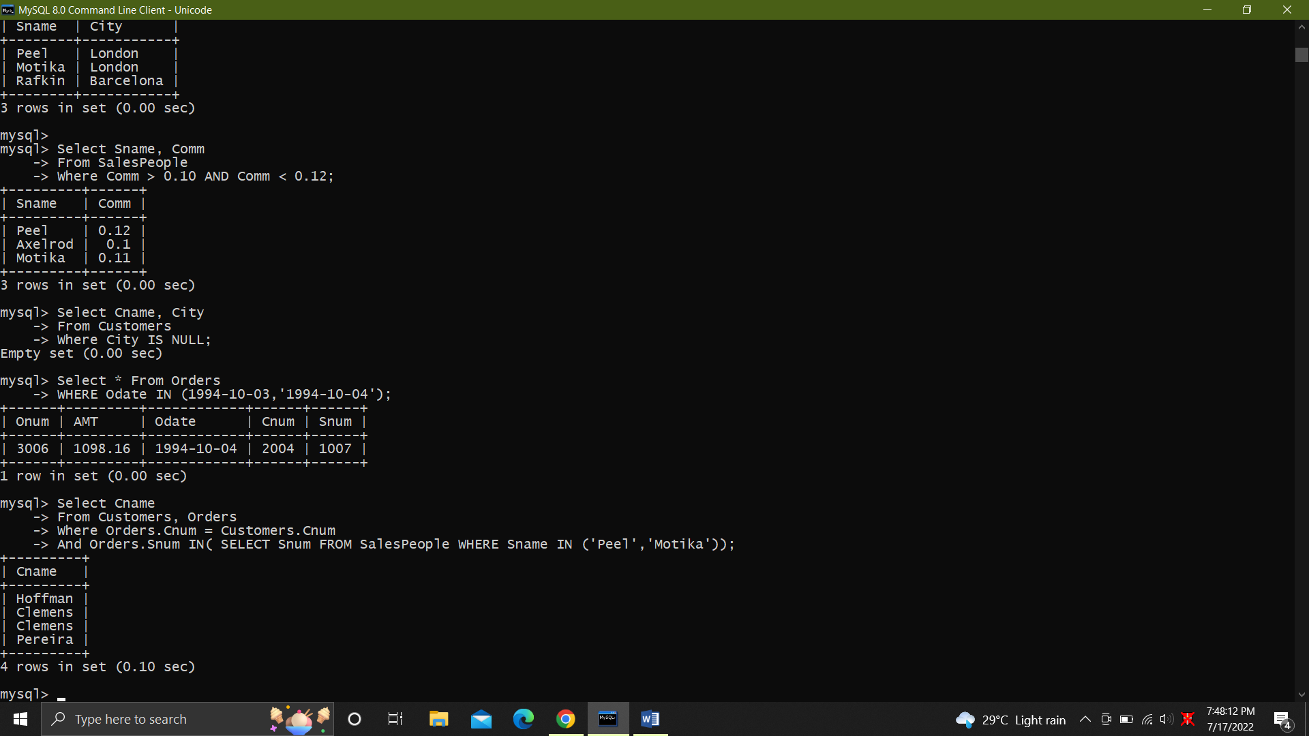

16. All customers whose names begin with a letter from A to B.

SELECT Cname

FROM customers

WHERE Cname LIKE 'A%' OR Cname LIKE 'B%';

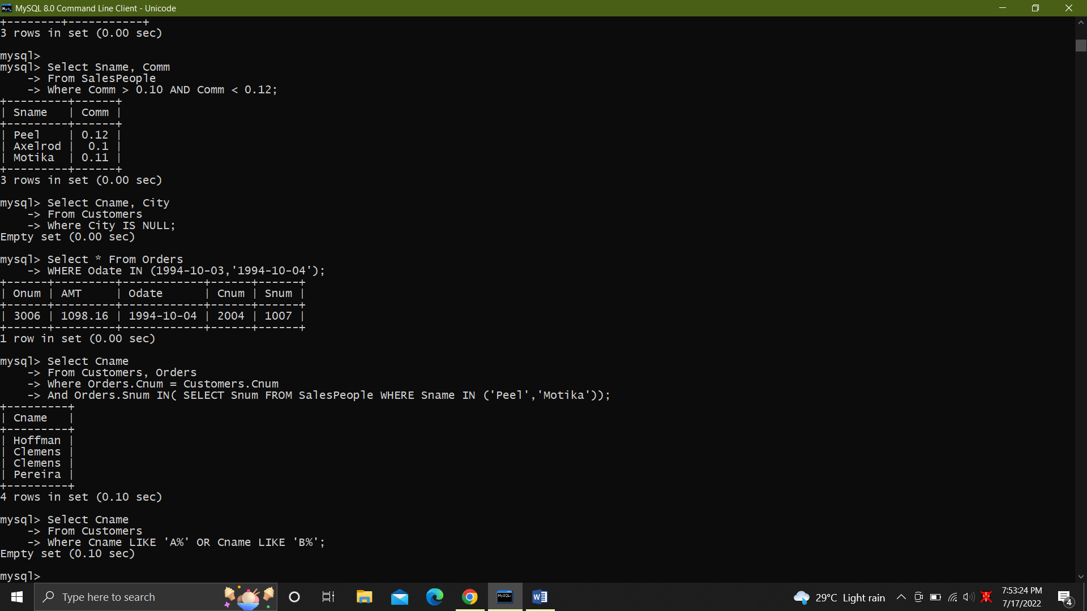

17. All orders except those with 0 or NULL value in amt field.

SELECT *

FROM Orders

WHERE AMT != 0 OR AMT IS NOT NULL;

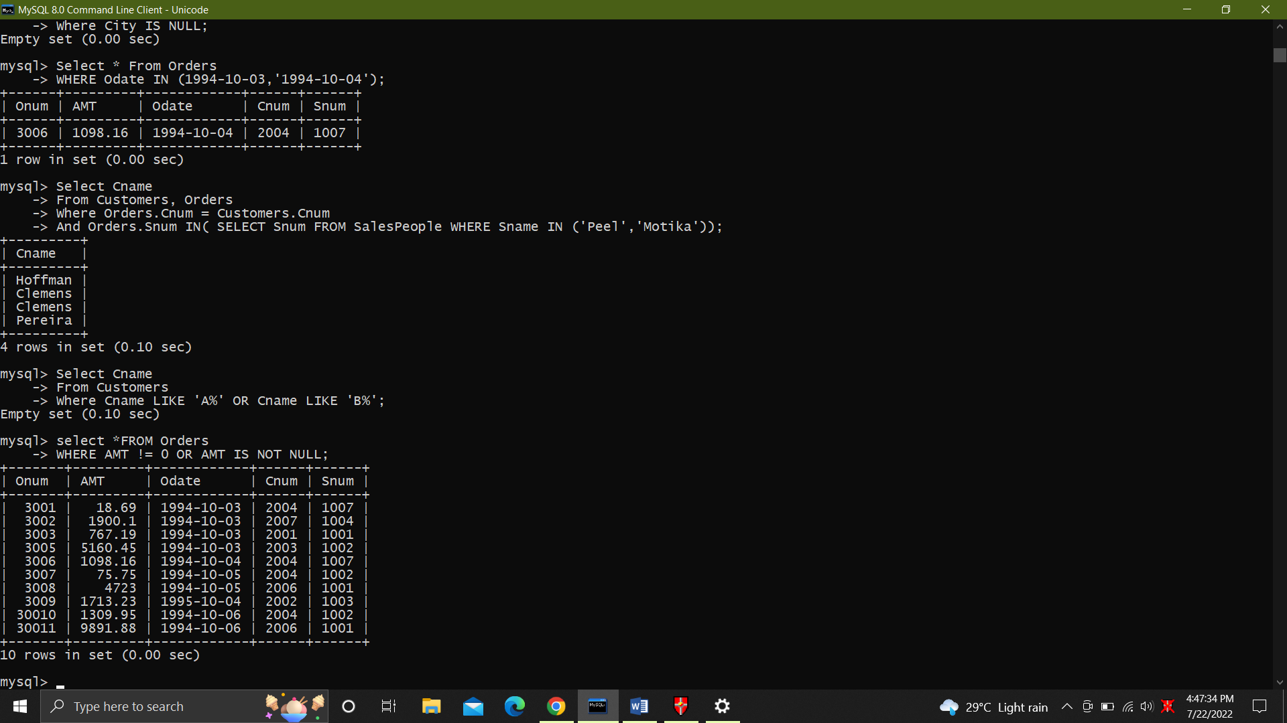

18. Count the number of salespeople currently listing orders in the order table.

SELECT COUNT(DISTINCT Snum) AS 'salespeople currently listing orders'

FROM Orders;

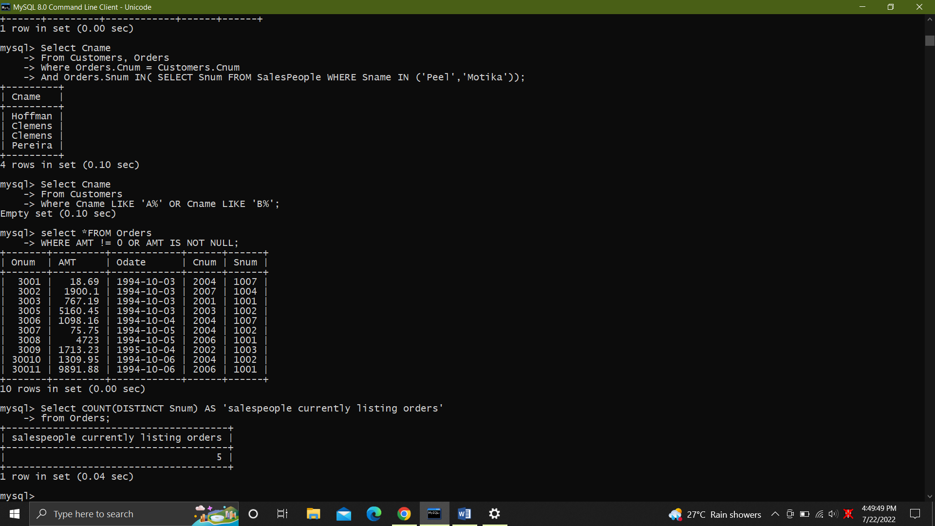

19. Largest order taken by each salesperson, datewise

SELECT Snum, Odate, MAX(AMT) AS 'Largest order'

FROM Orders

GROUP BY Odate, Snum

ORDER BY Odate,Snum;

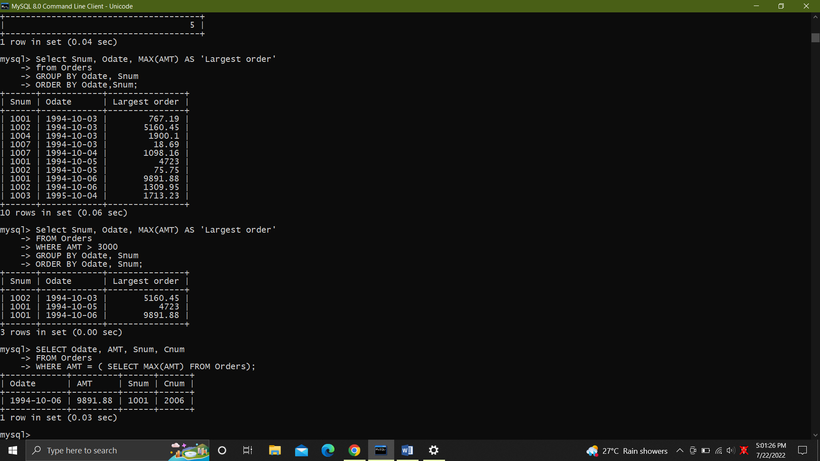

20.Largest order taken by each salesperson with order value more than $3000.

SELECT Snum, Odate, MAX(AMT) AS 'Largest order'

FROM Orders

WHERE AMT > 3000

GROUP BY Odate, Snum

ORDER BY Odate, Snum;



21. Which day had the hightest total amount ordered.

SELECT Odate, AMT, Snum, Cnum

FROM Orders

WHERE AMT = ( SELECT MAX(AMT) FROM Orders);



22. 22.Count all orders for Oct 3rd.

SELECT COUNT(*) AS 'Orders on Oct 3rd'

FROM Orders

WHERE Odate = '1994-10-03';

23. Count the number of different non NULL city values in customers table.

SELECT COUNT(DISTINCT City)

FROM customers;

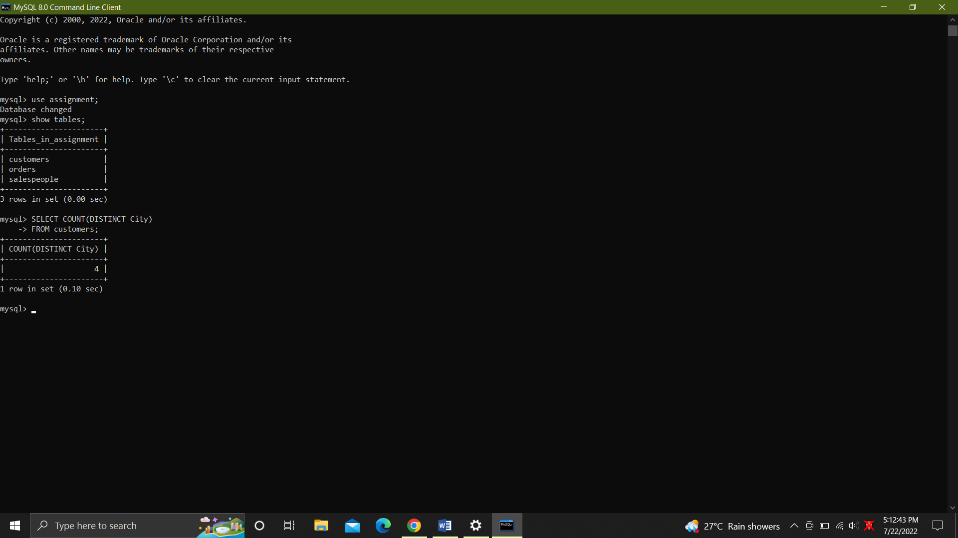

24. Select each customer’s smallest order.

SELECT Cnum, MIN(AMT)

FROM Orders

GROUP BY Cnum;

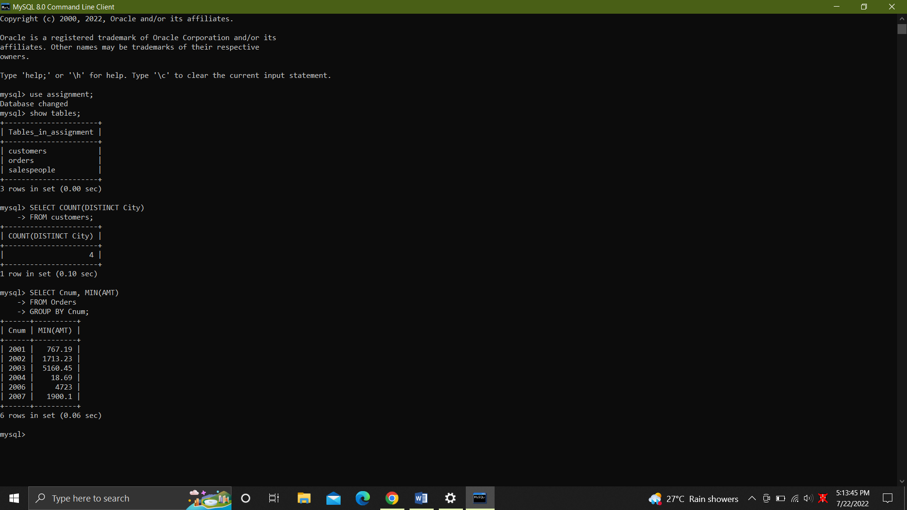

25. First customer in alphabetical order whose name begins with G.

SELECT MIN(Cname)

FROM customers

WHERE Cname LIKE 'G%';

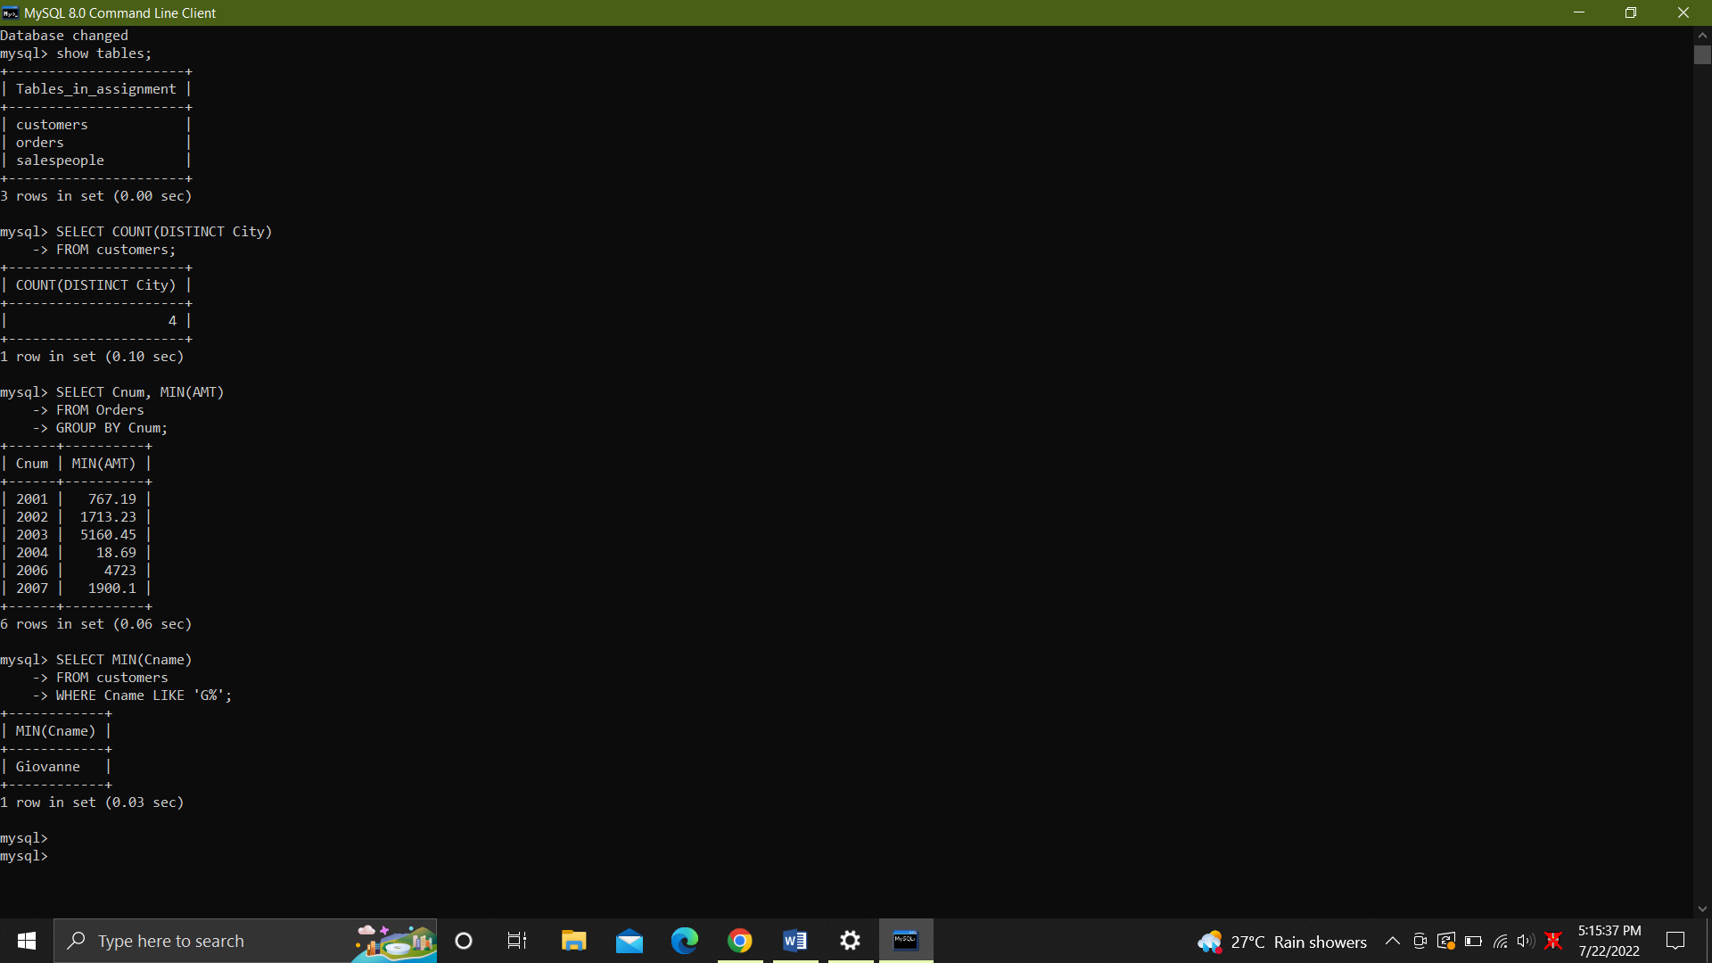

26. Get the output like “ For dd/mm/yy there are ___ orders.

-- SELECT 'For' (CONVERT(varchar(10), GETDATE(),120)) || 'there are' || COUNT(*) || 'Orders'

-- FROM Orders

-- GROUP BY Odate;

27. Assume that each salesperson has a 12% commission. Produce order no., salesperson no.,

--and amount of salesperson’s commission for that order.

SELECT Onum, Snum, AMT, AMT * 0.12 AS 'Commission'

FROM Orders

ORDER BY Snum;

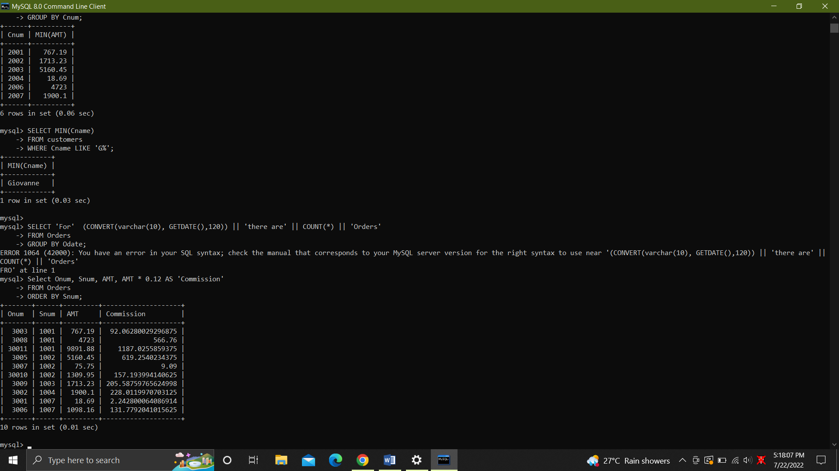

28. Find highest rating in each city. Put the output in this form. For the city (city),

the highest rating is : (rating).

Select 'For the city (' || City || '), the highest rating is : (' || MAX(Rating) || ')'

FROM Customers

GROUP BY city;

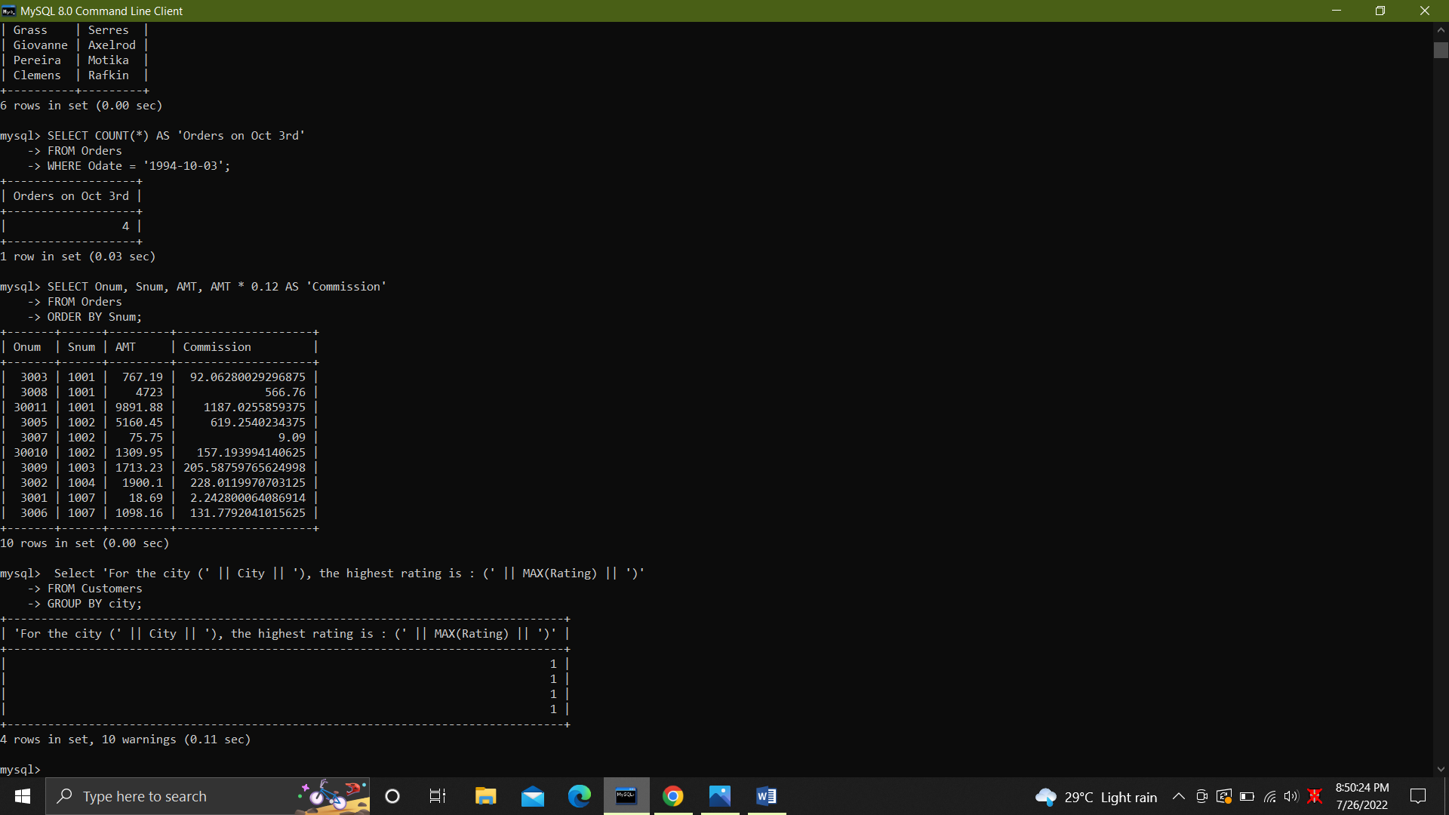

29.Display the totals of orders for each day and place the results in descending order.

SELECT Odate, COUNT(Onum) AS 'Total No of Orders'

FROM Orders

GROUP BY Odate

ORDER BY COUNT(Onum) DESC;

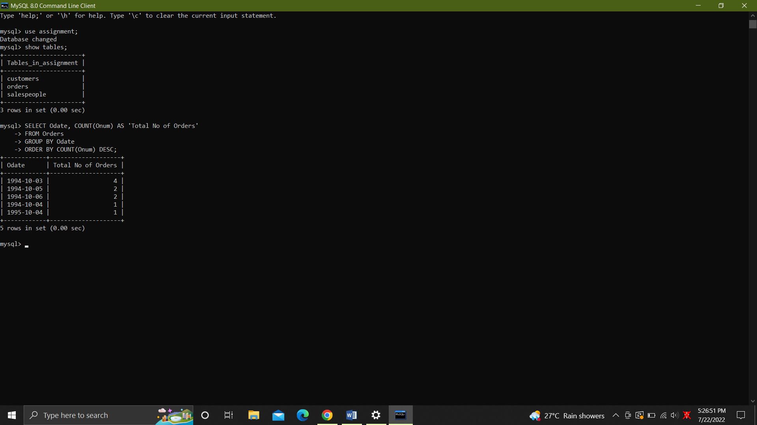

30..All combinations of salespeople and customers who shared a city. (ie same city).

SELECT Sname, Cname, S.City AS City

FROM SalesPeople AS S, Customers AS C

WHERE S.City = C.City;

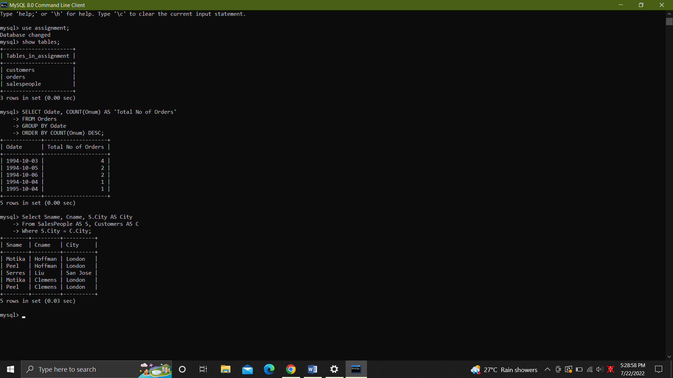

31. Name of all customers matched with the salespeople serving them

SELECT Cname, Sname

FROM Customers AS C, SalesPeople AS S

WHERE C.Snum = S.Snum;

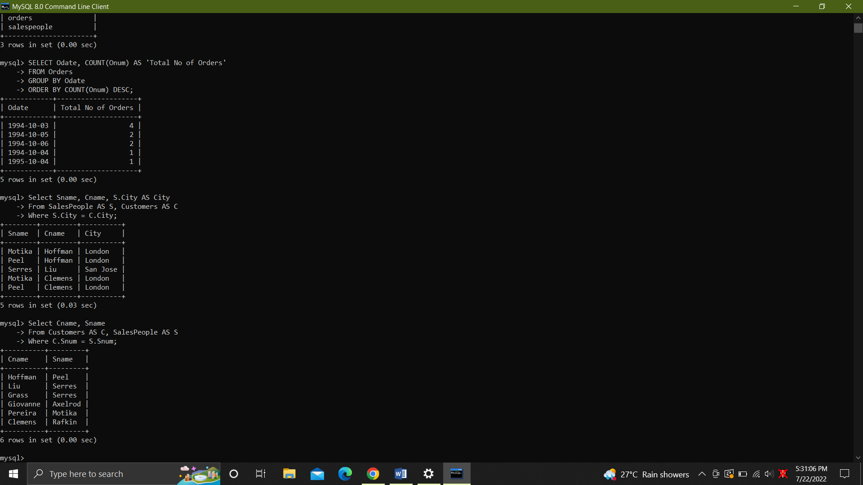

32. List each order number followed by the name of the customer who made the order.

SELECT Onum, Cname

FROM customers AS C, Orders AS O

WHERE O.Cnum = C.Cnum;

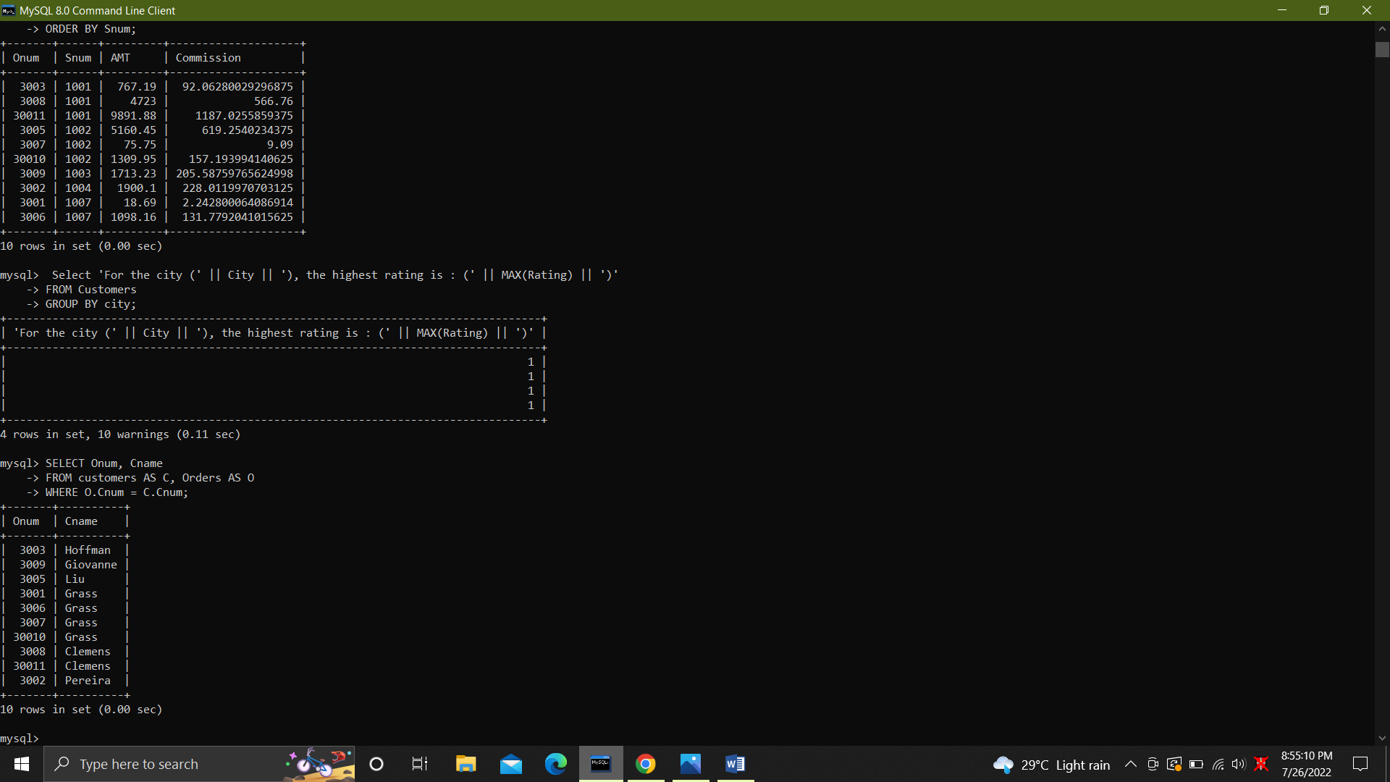

33. .Names of salesperson and customer for each order after the order number.

SELECT Onum, Sname, Cname

FROM Orders AS O, customers AS C, SalesPeople AS S

WHERE O.Cnum = C.Cnum and O.Snum = S.Snum;

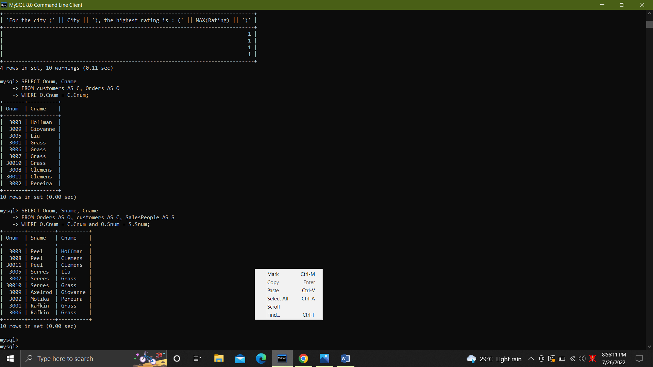

34. Produce all customer serviced by salespeople with a commission above 12%.

SELECT Cname, Sname, Comm

FROM customers AS C, SalesPeople AS S

WHERE Comm > 0.12 AND C.Snum = S.Snum;

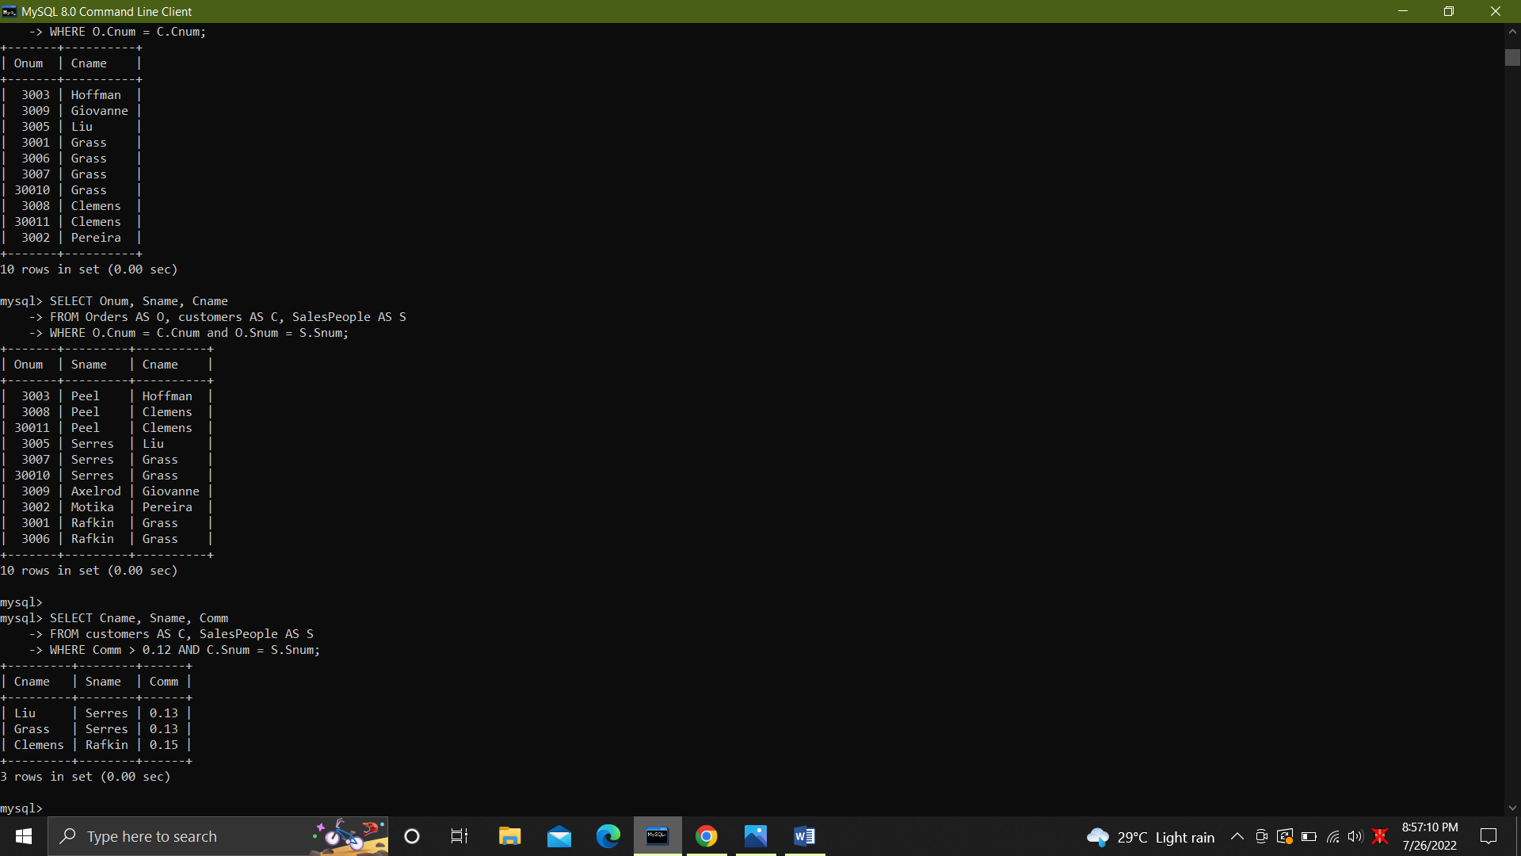

35. Calculate the amount of the salesperson’s commission on each order with a rating above 100.

SELECT Sname, AMT*Comm, Rating

FROM customers AS C, SalesPeople AS S, Orders AS O

WHERE Rating > 100 AND

S.Snum = C.Snum AND

S.Snum = O.Snum AND

O.Cnum = C.Cnum;

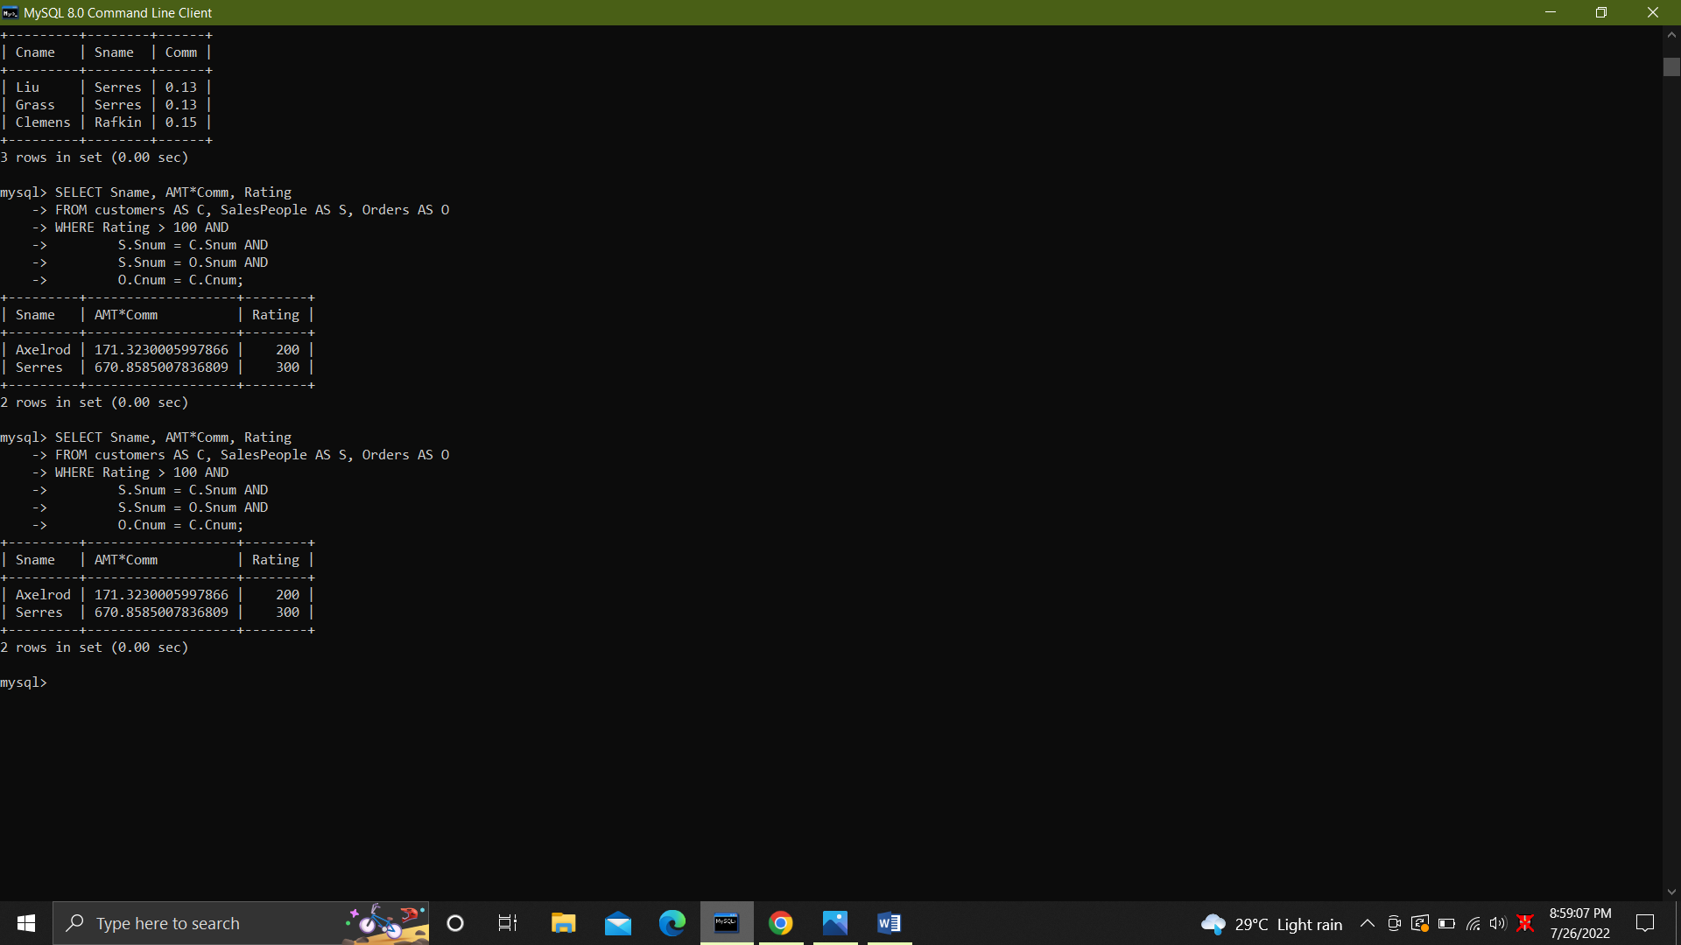

36. Find all pairs of customers having the same rating.

SELECT a.Cname, b.Cname, a.Rating

FROM customers a, customers b

WHERE a.Rating = b.Rating and a.Cnum != b.Cnum;

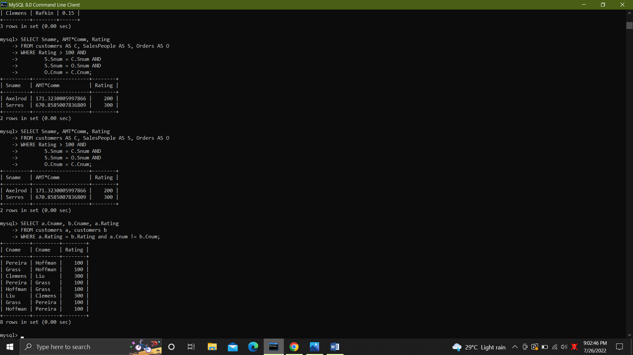

37. Find all pairs of customers having the same rating, each pair coming once only.

SELECT a.Cname, b.Cname, a.Rating

FROM customers a, customers b

WHERE a.Rating = b.Rating AND a.Cnum != b.Cnum AND a.Cnum < b.Cnum;

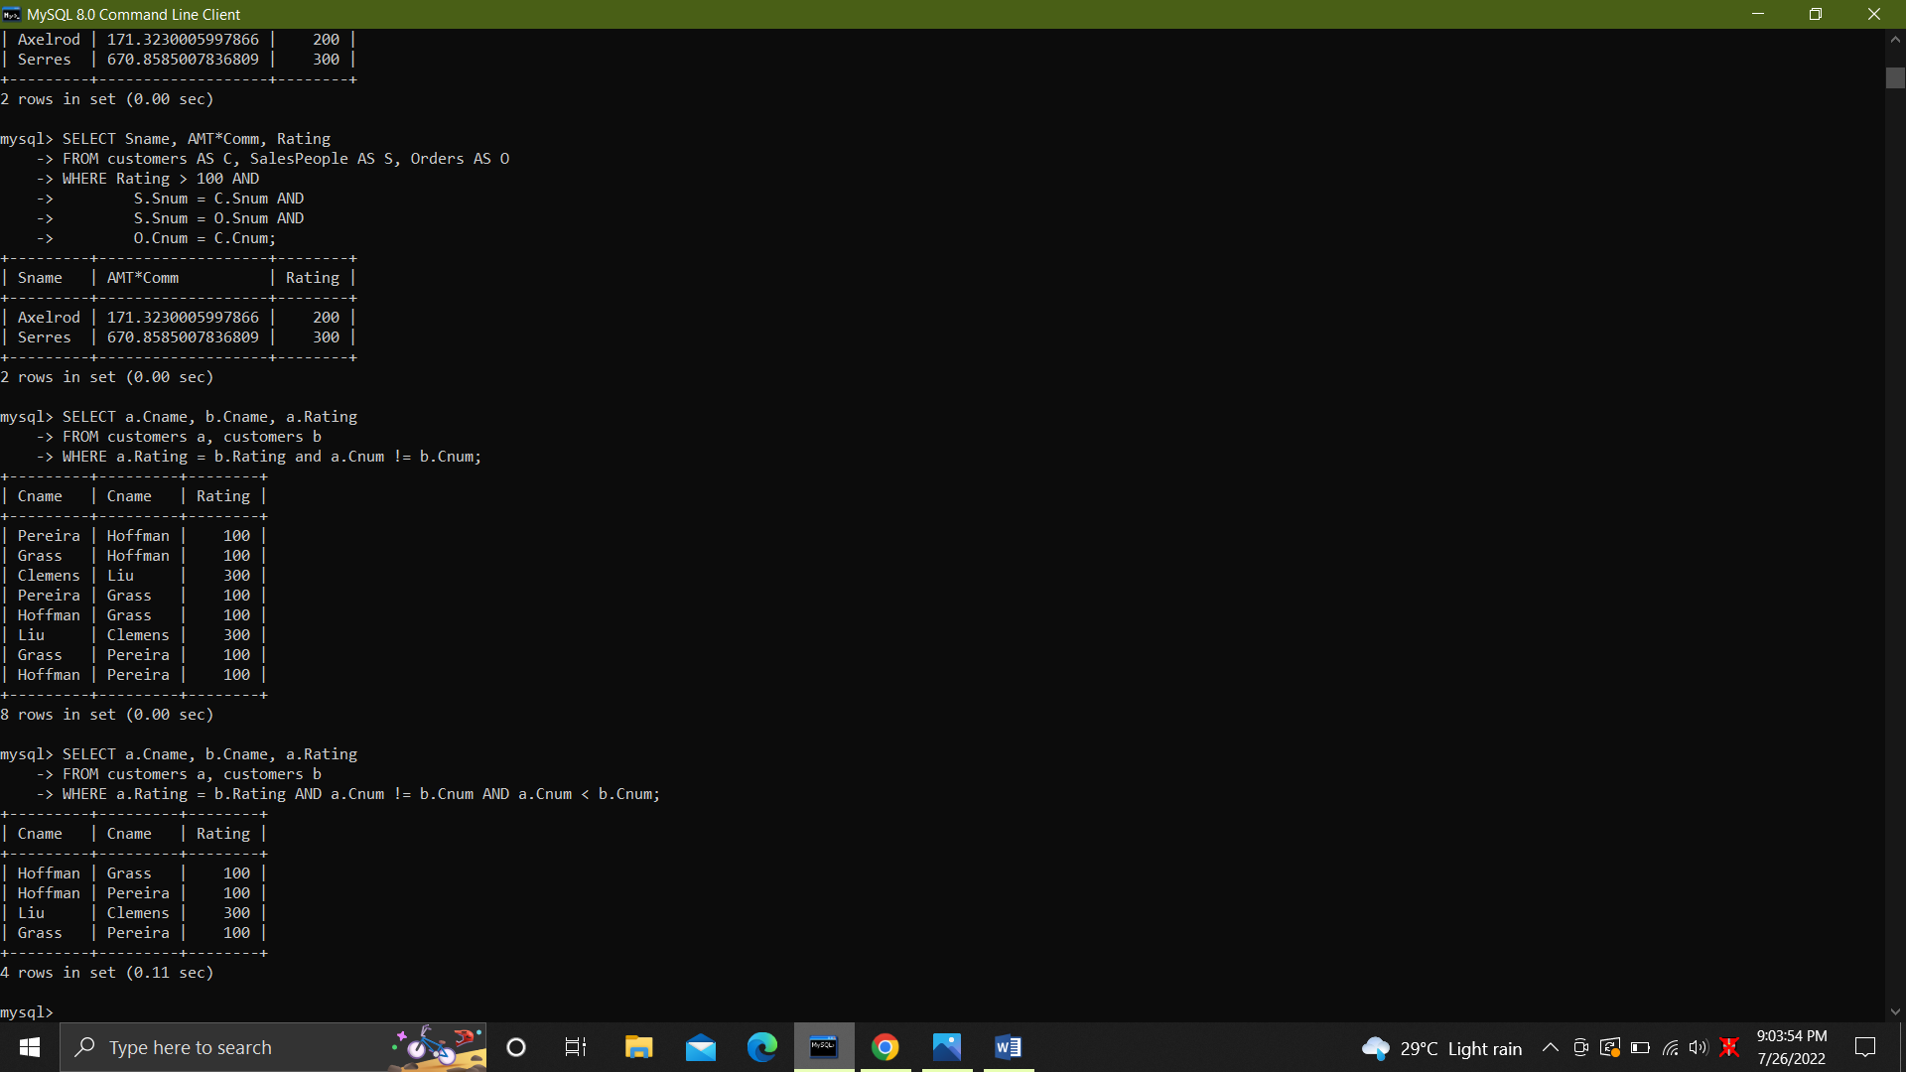

38. Policy is to assign three salesperson to each customers. Display all such combinations.

Select Cname, Sname

FROM SalesPeople, customers

WHERE Sname IN

( SELECT Sname FROM salespeople WHERE rownum <= 3)

ORDER BY Cname;

39.Display all customers located in cities where salesman serres has customer.

SELECT Cname

FROM Customers

WHERE City IN ( SELECT City FROM Customers AS C, Orders AS O

WHERE C.Cnum = O.Cnum AND

O.Snum IN ( SELECT Snum FROM SalesPeople

WHERE Sname = 'Serres'));

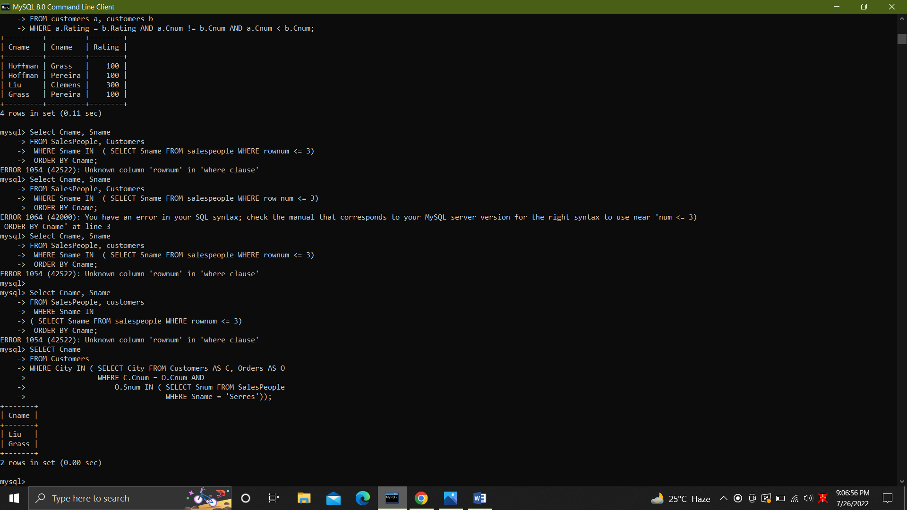

40. Find all pairs of customers served by single salesperson.

SELECT DISTINCT a.Cname

FROM customers a , customers b

WHERE a.Snum = b.Snum and a.Cnum != b.Cnum;

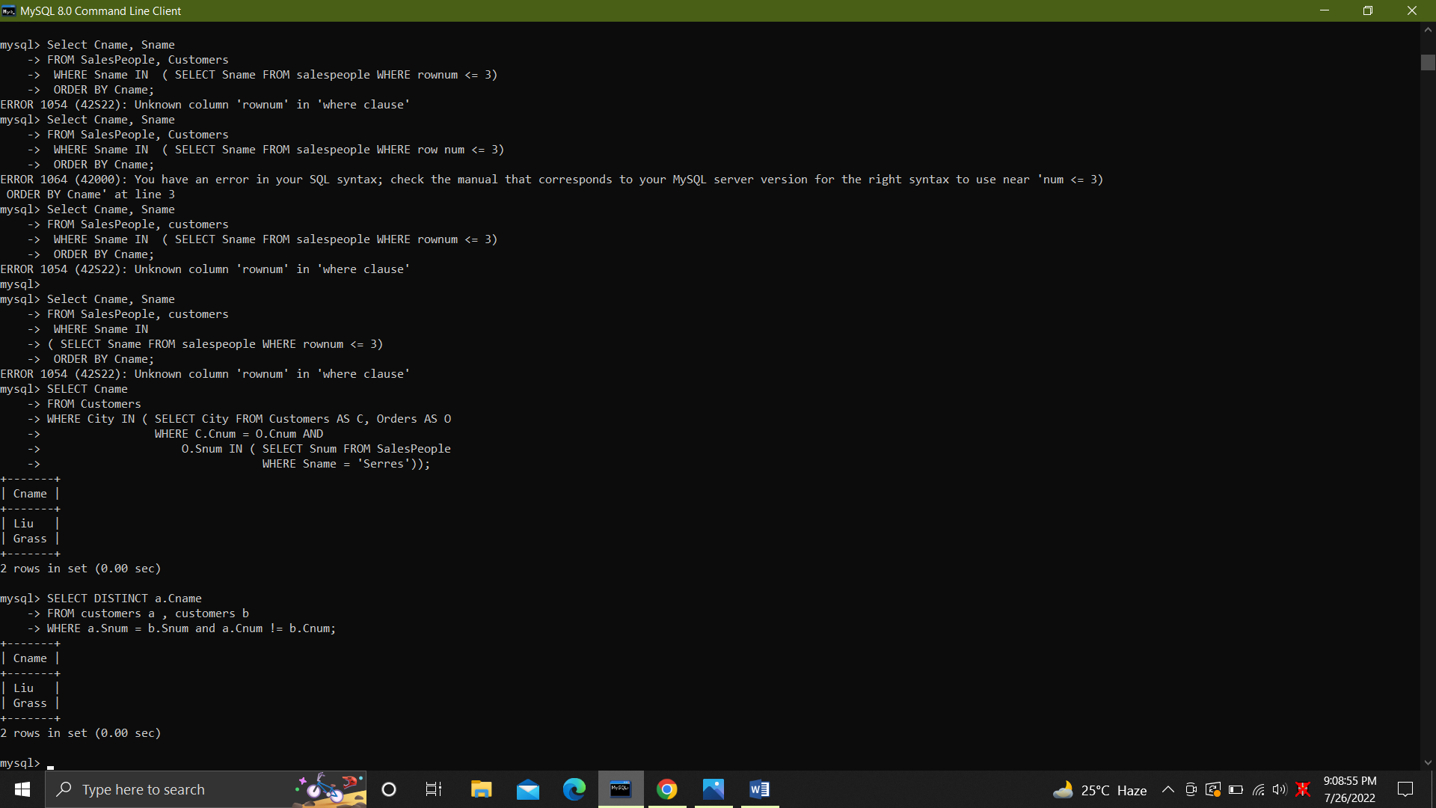

41. Produce all pairs of salespeople which are living in the same city. Exclude combinations of salespeople with themselves as well as duplicates with the order reversed.

SELECT a.Sname, b.Sname

FROM SalesPeople a, SalesPeople b

WHERE a.Snum > b.Snum AND a.City = b.City;

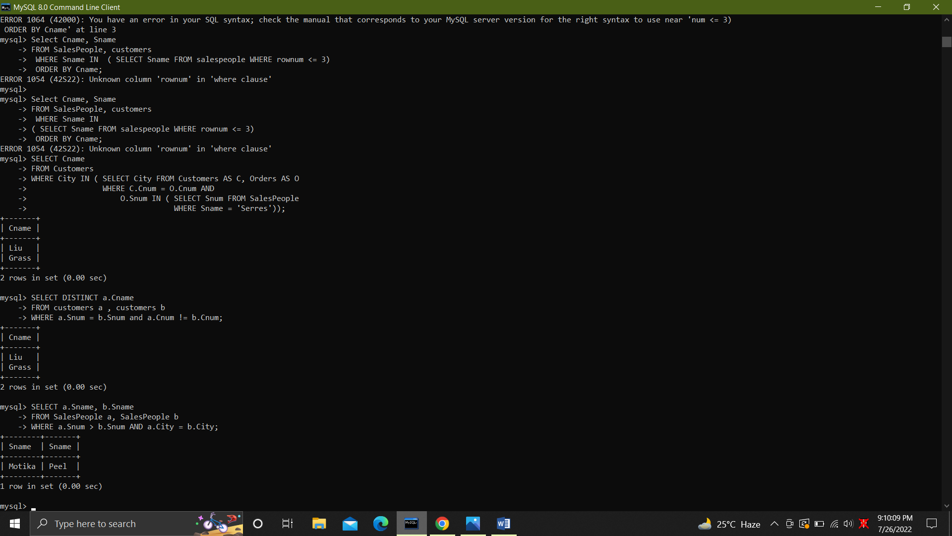

42. Produce all pairs of orders by given customer, names that customers and eliminates duplicates.

SELECT c.Cname, a.Onum, b.Onum

FROM Orders a, Orders b, Customers c

WHERE a.Cnum = b.Cnum AND

a.Onum > b.Onum AND

c.Cnum = a.Cnum;

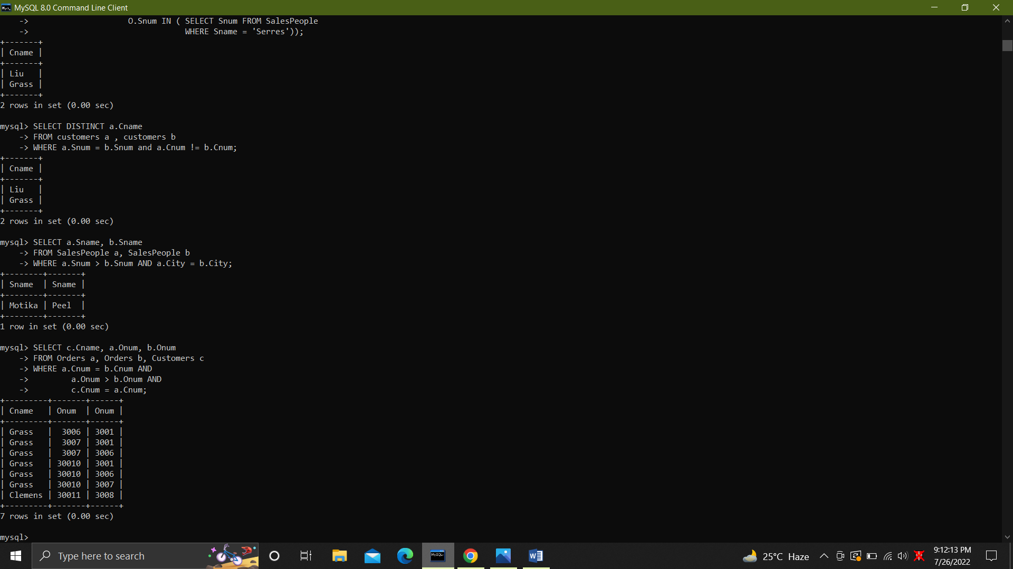

43. Produce names and cities of all customers with the same rating as Hoffman.

SELECT Cname, City

FROM customers

WHERE Rating = (SELECT Rating FROM customers WHERE Cname = 'Hoffman') AND Cname != 'Hoffman';

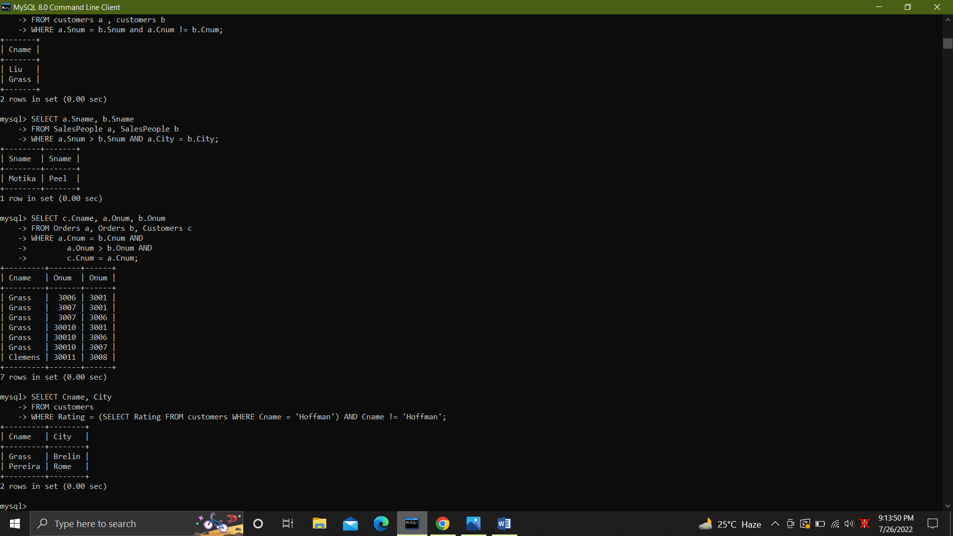

44. Extract all the orders of Motika.

SELECT Onum

FROM Orders

WHERE Snum = ( SELECT Snum FROM SalesPeople WHERE Sname = 'Motika');

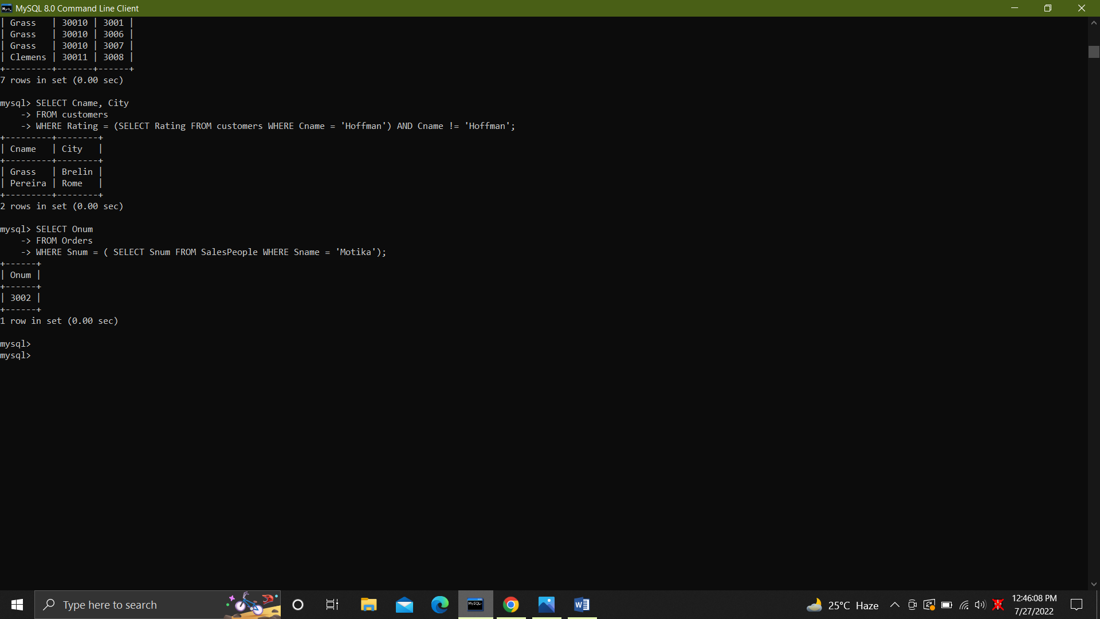

45. All orders credited to the same salesperson who services Hoffman

SELECT Onum, sname, Cname, AMT

from Orders AS O, SalesPeople AS S, Customers C

where O.Snum = S.Snum AND O.Cnum = C.Cnum AND

O.Snum = ( SELECT Snum FROM Orders

WHERE Cnum = ( SELECT Cnum FROM Customers

WHERE Cname = 'Hoffman'));

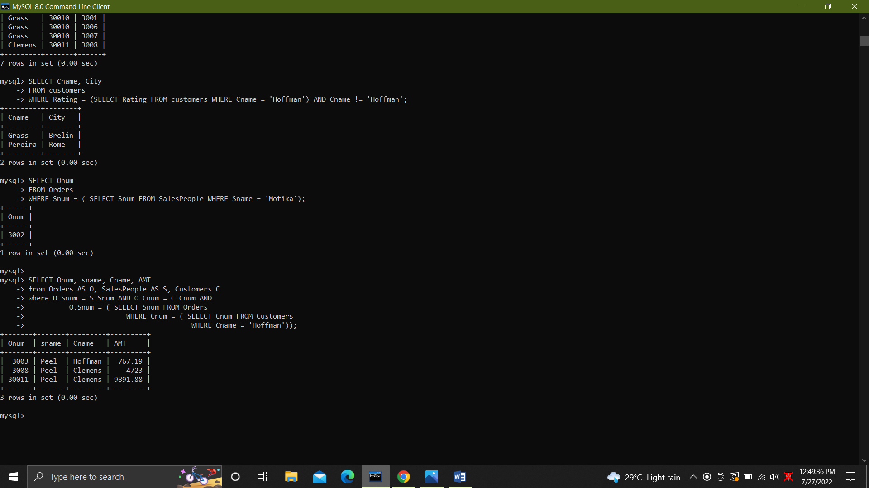

46. All orders that are greater than the average for Oct 4.

SELECT *FROM Orders

WHERE AMT > ( SELECT AVG(AMT) FROM Orders

WHERE Odate = '1994-10-03');

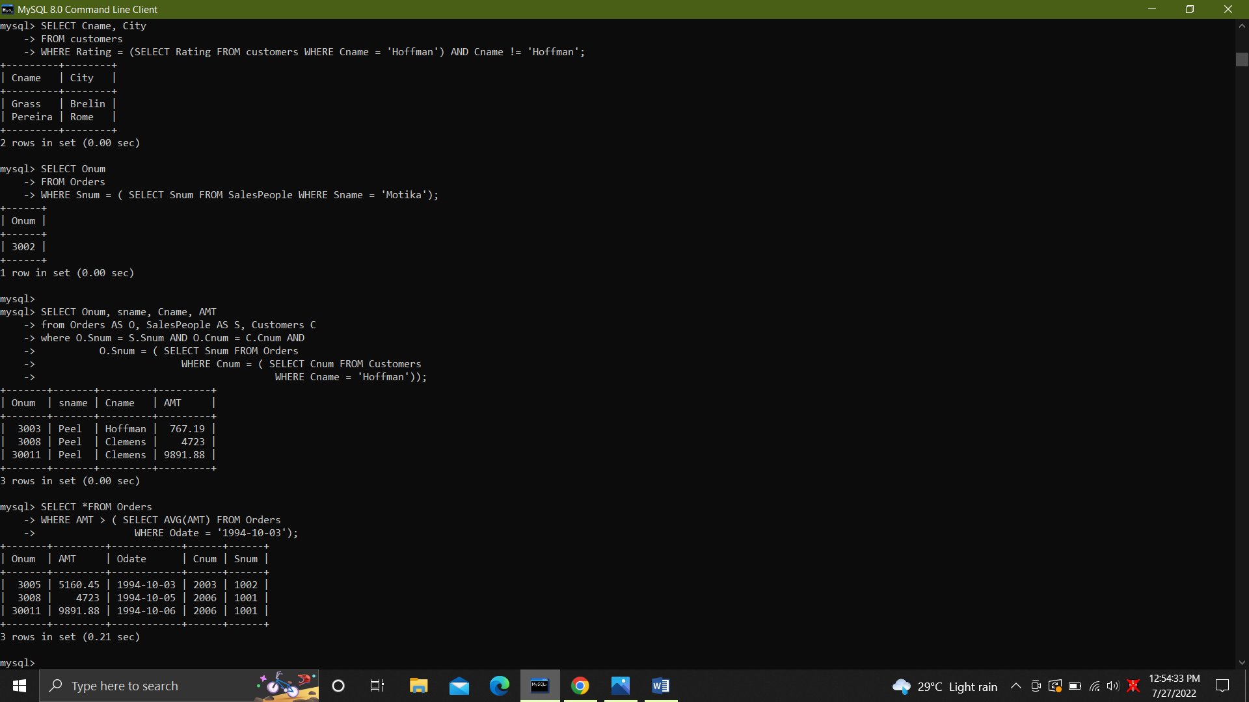

47. Find average commission of salespeople in london.

SELECT AVG(Comm) FROM SalesPeople WHERE City = 'London';

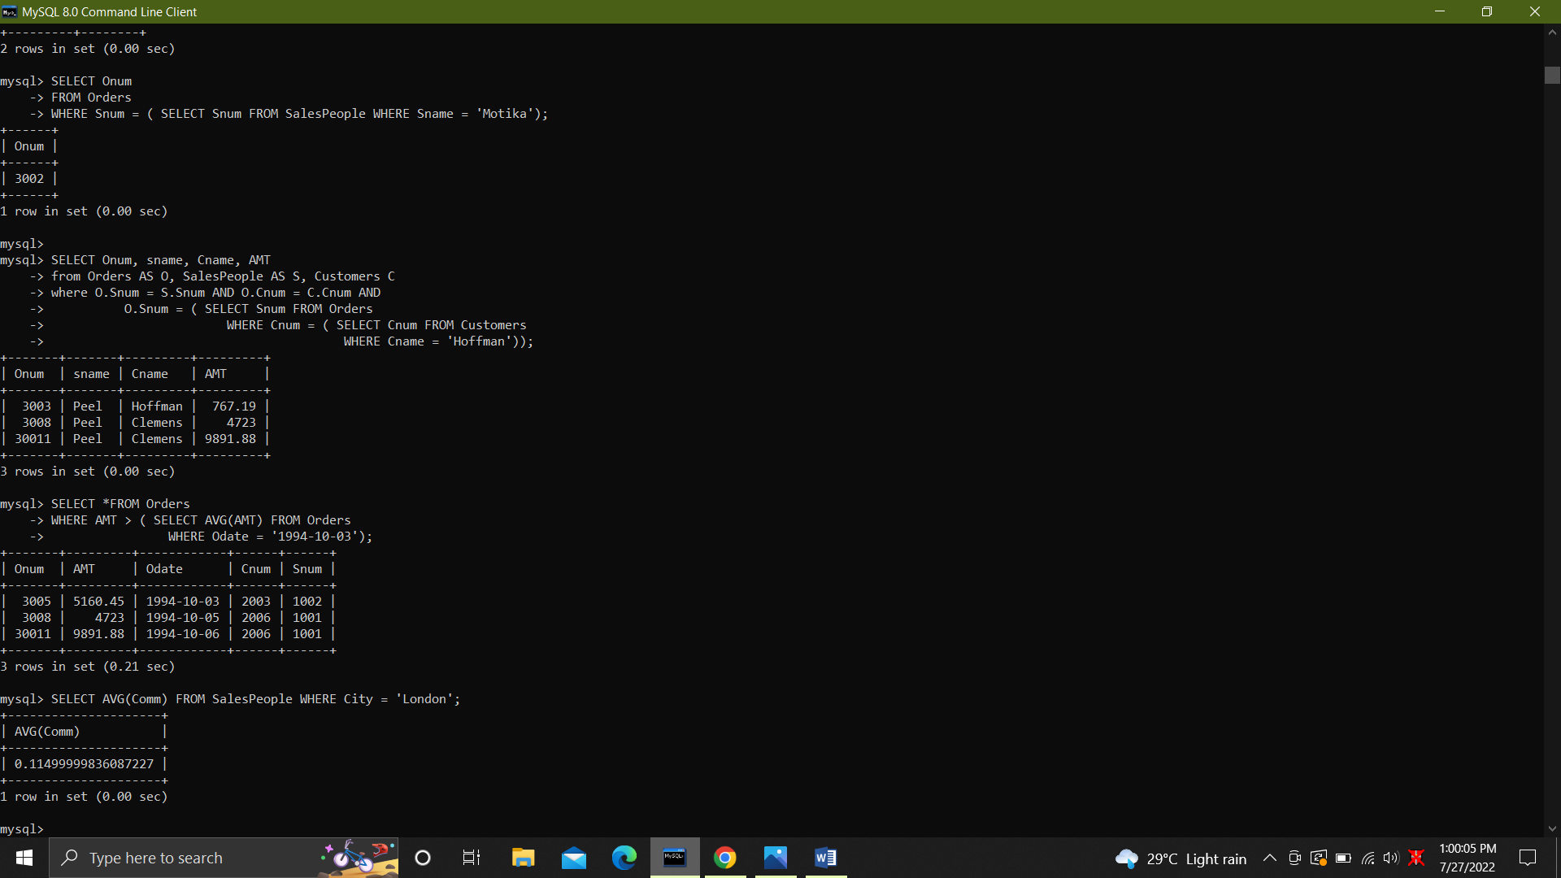

48. Find all orders attributed to salespeople servicing customers in london.

SELECT Snum, Cnum

FROM Orders

WHERE Cnum IN (SELECT Cnum FROM customers WHERE City = 'London');

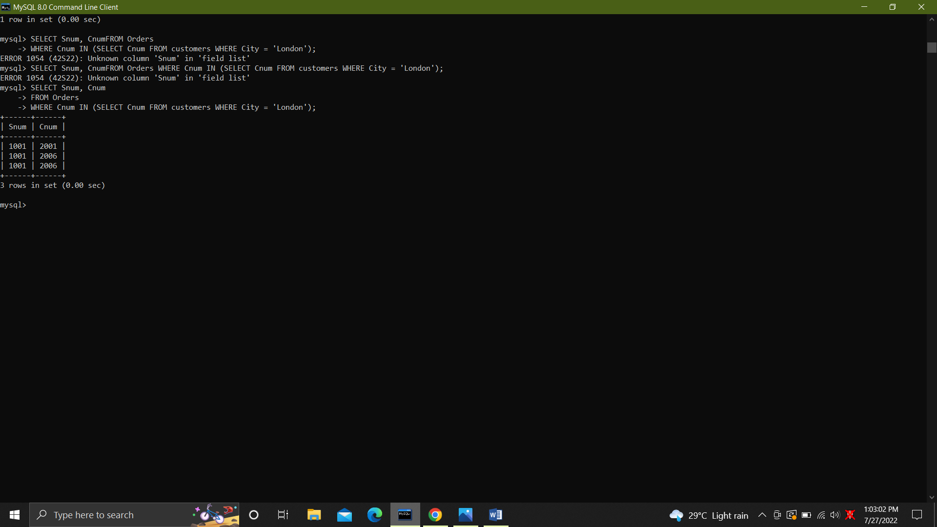

49. Extract commissions of all salespeople servicing customers in London.

SELECT Comm

FROM SalesPeople

WHERE Snum IN (SELECT Snum FROM Customers WHERE City = 'London');

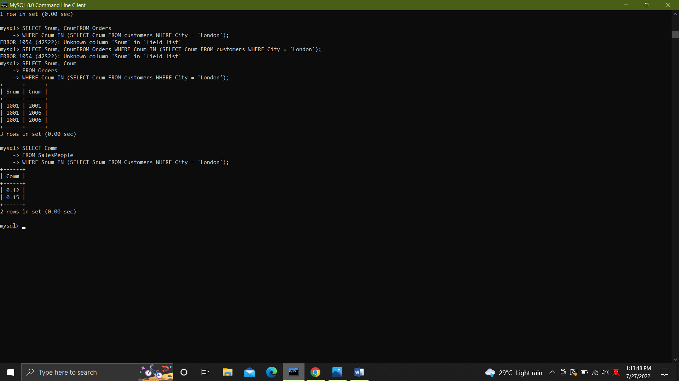

50. .Find all customers whose cnum is 1000 above the snum of serres.

SELECT Cnum, Cname from Customers

where Cnum > ( SELECT Snum + 1000

FROM SalesPeople

WHERE Sname = 'Serres');

